
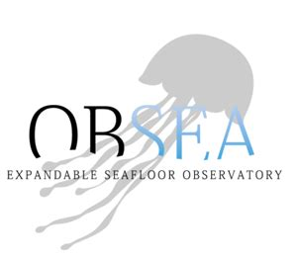
« Rambla de l'Exposició, 24, 08800 Vilanova i la Geltrú, Barcelona, Espagne »
Tutor
DEL RIO Joaquin
Aggragated professor,+34 609926966
DATE AND SIGNATURE OF THE TUTOR
Done from 15/06/2026 to 18/09/2026 (3 weeks break in August) at Universitat Politècnica Catalunya (SARTI)
Institut Supérieur de l’Électronique et du Numérique
Tél. : +33 (0)2.98.03.84.00
Fax : +33 (0)2.98.03.84.10
20, rue Cuirassé Bretagne
CS 42807 – 29228 BREST Cedex 2 - FRANCE
M1
Scholar year 2025/2026
Application internship
ISEN Correspondant
QUEUDET Frédéric
Student
PAROT Nathan
option : Energy
« NMEA2000 to Wi-Fi Monitoring System »

Acknowledgements
The work presented in this report was carried out at the SARTI research centre of the Universitat Politècnica de Catalunya, in Vilanova i la Geltrú. The quality of the reception given to a visiting student, and the degree of technical autonomy that was granted from the first week, contributed directly to the results described in the following chapters.
Thanks are due to Joaquin DEL RIO, who supervised the internship, for the definition of a subject that was both open and precisely bounded, for the access granted to the instrumented vessel and to the laboratory equipment, and for the time spent reviewing the technical choices at each stage of the project.
Thanks are due to all the people in the Centre Technològic de Vilanova i la Geltrú for their precious help at all times and their hospitality.
Finally, thanks are due to Frédéric QUEUDET for the academic follow-up of this internship, and to the international relations department of ISEN Brest for making this placement abroad possible.

Table of contents
Acknowledgements 1
Glossary 4
1. Introduction 6
2. Presentation of the host organisation 7
2.1 The Universitat Politècnica de Catalunya 7
2.2 The SARTI research centre 7
2.3 The OBSEA observatory 8
2.4 Position of the internship within the group's activity 9
3. Context 10
3.1 The existing installation 10
3.2 The shore infrastructure 10
3.3 The initial request 10
3.4 Social responsibility and sustainable development 10
4. Technical objectives and specification 12
4.1 Functional requirements 12
4.2 Boundaries of the study 12
5. Technical development 13
5.1 Approach and phases of the work 13
5.2 The NMEA 2000 network 14
5.2.1 Principle 14
5.2.2 Physical layer and wiring 14
5.2.3 Structure of a message 16
5.2.4 Single-frame and fast-packet messages 16
5.2.5 Network management 17
5.2.6 Devices of the vessel and their PGNs 17
5.3 The ESP32-S3 board and its CAN interface 17
5.4 Simulation bench with two ESP32 boards 19
5.4.1 Principle 19
5.4.3 Advantages and limits of the bench 21
5.5 Decoding, processing and display 21
5.5.1 Processing of a frame 21
5.5.2 Reading the frames in idf.py monitor 22
5.5.3 Reading a fast-packet message in the monitor 23
5.5.4 Frequencies of the PGNs 24
5.6 Explanation of the PGNs 25
5.6.1 PGN 129025 - Position, rapid update 25
5.6.2 PGN 129026 - Course and speed over ground 25
5.6.3 PGN 129029 - GNSS position data 25
5.6.4 PGN 129033 and 126992 - Time and date 26
5.6.5 PGN 129539 and 129540 - Quality of the fix 26
5.6.6 PGN 129038 and 129039 - AIS position reports 27
5.6.7 PGN 127488 and 127489 - Engine parameters 27
5.7 Tests on board the vessel 27
5.8 Local display and link to the laboratory 29
5.8.1 Local web page (LAN) 29
5.8.2 Link to the laboratory server (WAN) 29
5.9 Problems encountered and their resolution 30
5.10 Limits and points of improvement 31
6. Project management 34
6.1 Autonomy and supervision 34
6.2 Chronology of the work 34
6.3 Organisation of the tests on board 35
6.4 Working method 35
6.5 Difficulties and how they were handled 35
6.6 Handover 36
7. Conclusion 37
Bibliography 38
Annexes 39
Annexe A - Wiring table of the acquisition node 39
Annexe B - Provisioning of the server entities 39
Annexe C - Publication payload 39
Annexe D - Decoding of a parameter group 39
Annexe E - Bill of materials and indicative cost 40
Annexe F - Photographic record 40

Glossary
The following acronyms and technical terms are used throughout this report. Each one is also expanded at its first occurrence in the text.
AIS Automatic Identification System. Maritime traffic monitoring system that broadcasts the identity, position and course of equipped vessels.
API Application Programming Interface. Set of operations exposed by a software component for use by another component.
CAN Controller Area Network. Serial bus standard (ISO 11898) used as the physical and data-link layer of NMEA 2000.
COG Course Over Ground. Direction of the vessel's movement relative to the seabed.
CSRD Corporate Sustainability Reporting Directive. European directive on the publication of sustainability information.
DDRS Développement Durable et Responsabilité Sociétale. Academic equivalent of corporate social responsibility.
DHCP Dynamic Host Configuration Protocol. Automatic allocation of network addresses.
ESP-IDF Espressif IoT Development Framework. Official development framework for ESP32 microcontrollers.
FROST Fraunhofer Open Source SensorThings. Open-source server implementing the OGC SensorThings API.
GNSS Global Navigation Satellite System. Generic term covering GPS, Galileo, GLONASS and BeiDou.
GPIO General Purpose Input Output. Configurable digital pin of a microcontroller.
HDOP Horizontal Dilution of Precision. Indicator of the quality of a GPS fix due to the position of the satellites.
HTTP HyperText Transfer Protocol. Application protocol used for the REST interface of the server.
ISR Interrupt Service Routine. Function executed in interrupt context, with strong constraints on execution time.
JSON JavaScript Object Notation. Text format used for the payload of the published observations.
LAN Local Area Network. Here, the Wi-Fi network created on board by the ESP32 access point.
LEN Load Equivalency Number. Unit of electrical load of a device connected to an NMEA 2000 backbone.
MMSI Maritime Mobile Service Identity. Nine-digit identifier of a vessel, used by the AIS.
MQTT Message Queuing Telemetry Transport. Lightweight publish and subscribe protocol designed for constrained devices.
NMEA 2000 Standard for serial data networking of marine electronic devices, published by the National Marine Electronics Association.
NTP Network Time Protocol. Protocol for clock synchronisation over a network.
OBSEA Expandable Seafloor Observatory operated by SARTI off Vilanova i la Geltrú.
OGC Open Geospatial Consortium. Standards body responsible for the SensorThings API specification.
PGN Parameter Group Number. Identifier that defines the meaning and layout of an NMEA 2000 message.
PostGIS Spatial extension of the PostgreSQL database management system.
REST Representational State Transfer. Architectural style used by the HTTP interface of FROST-Server.
RSE Responsabilité Sociétale des Entreprises. French term for corporate social responsibility.
SARTI Sistemes d'Adquisició Remota i Tractament de la Informació. Research centre of the UPC hosting the internship.
SDG Sustainable Development Goal. One of the seventeen goals defined by the United Nations.
SOG Speed Over Ground. Speed of the vessel relative to the seabed.
STA SensorThings API. OGC standard for the exposure of sensor observations over the web.
STW Speed Through the Water. Speed of the vessel relative to the water, measured by a log.
TLS Transport Layer Security. Cryptographic protocol securing the HTTP and MQTT transport.
TWAI Two-Wire Automotive Interface. Name given by Espressif to the CAN controller integrated in the ESP32.
UPC Universitat Politècnica de Catalunya. Host university of the internship.
VHF Very High Frequency. Radio band used by maritime communications and by the AIS.
WAN Wide Area Network. Here, the internet link between the vessel and the laboratory server.
List of figures
Figure 1: Host site: Centre Tecnologic de Vilanova I la geltru (CTVG), UPC Vilanova i la Geltrú campus 8
Figure 2: The three phases of the project, from the simulation bench to the remote database 13
Figure 3: Final acquisition chain, from the vessel equipment to the laboratory 14
Figure 4: Backbone of the vessel, devices connected and position of the ESP32 receiver 15
Figure 5: M12 five-pin pinout and connection of the ESP32 board to the network 15
Figure 6: Structure of the 29-bit identifier and PGNs sent by the GPS receiver of the vessel 16
Figure 7: Transport of a message longer than 8 bytes in several frames (fast-packet) 17
Figure 8: Position of the main equipment on board the vessel (schematic side view) 17
Figure 9: ESP32-S3 board and CAN transceiver used as receiver 19
Figure 10: Simulation bench: one ESP32 sends PGNs, the other receives and decodes them 19
Figure 11: Processing of a frame and the three outputs used during the project 21
Figure 12: Frames and decoded values displayed in the ESP-IDF monitor 22
Figure 13: Estimated number of frames per second for each PGN and load of the bus 23
Figure 14: Heading and speed through the water compared with course and speed over ground 24
Figure 15: Test on board: ESP32 connected to the backbone through a T-connector 27
Figure 16: Local web page served by the ESP32 on its own Wi-Fi access point 28
Figure 17: Organisation of the data of the vessel in the SensorThings database 28
Figure 18: Problems met along the chain, their cause and their resolution 29
Figure 19: Installation as tested and target installation 30
Figure 20: Chronology of the internship and of the tests on board 32
Figure 19: Acquisition node: microcontroller module, transceiver and M12 connection 39
Figure 20: Installation of the node on the instrumented vessel 40
Figure 21: Local dashboard displaying live values during a sea trial 40
Figure 22: Observations retrieved from the production database over the REST interface 41

1. Introduction
Marine observation infrastructures rely on two complementary families of sensors. Fixed installations, such as cabled seafloor observatories, deliver long time series at a single point. Mobile platforms, and in particular working vessels, cover a much larger area but rarely contribute their measurements to any scientific database, because the data produced on board remain confined to the navigation instruments that display them.
Every recent vessel carries an NMEA 2000 network, an on-board digital bus on which position, heading, speed, depth, engine parameters and traffic information circulate continuously. That bus is a dense source of georeferenced measurements, already digitised and already timestamped. It is, however, a closed source: the data are broadcast for the benefit of the chart plotter and the engine display, they are not stored, and they are not accessible from shore.
This report describes the design, the implementation and the validation of an acquisition chain that opens that source. An embedded node based on an ESP32-S3 microcontroller listens to the NMEA 2000 backbone of an instrumented vessel, decodes the parameter groups of interest, and publishes the resulting observations to a database hosted by the SARTI research centre of the Universitat Politècnica de Catalunya. The database is a FROST-Server instance implementing the OGC SensorThings API, the same standard already used for the fixed sensors of the OBSEA observatory, so that mobile and fixed measurements can be queried through a single interface. A local web dashboard, served by the node itself, gives the crew an immediate view of the acquired quantities without any dependency on the shore link.
The work was carried out over eleven weeks, from 15/06/2026 to 18/09/2026 with a three weeks breaks in August due to the closing of UPC, within the SARTI research centre in Vilanova i la Geltrú, Spain.
The report is organised as follows. Chapter 2 presents the host organisation and its scientific activity. Chapter 3 sets out the context of the project, the state of the existing installation, the initial request, and a reflection on the social responsibility and sustainable development dimensions of the host laboratory and of the work performed. Chapter 4 formalises the technical objectives and the specification against which the result is assessed. Chapter 5 constitutes the core of the document: it describes a prior analysis of the problem, the architecture that was derived from it, the hardware and firmware implementation, the data model, the server deployment, the validation campaign, and a critical analysis of the choices that were made. Chapter 6 analyses the management of the project, the evolution of the technical decisions and their effect on the schedule. Chapter 7 concludes and states the perspectives, with an estimate of the effort and the material cost required to extend the work.

2. Presentation of the host organisation

2.1 The Universitat Politècnica de Catalunya
The Universitat Politècnica de Catalunya (UPC), also known as BarcelonaTech, is a public technical university specialised in engineering, architecture, science and technology. Its activity is distributed over several campuses in Catalunya, one of which is located in Vilanova i la Geltrú, a coastal town approximately fifty kilometres south of Barcelona. The Vilanova campus hosts the Escola Politècnica Superior d'Enginyeria de Vilanova i la Geltrú and several research groups attached to the Department of Electronic Engineering.

2.2 The SARTI research centre
The internship took place within SARTI, Sistemes d'Adquisició Remota i Tractament de la Informació, a research centre of the Department of Electronic Engineering located at the Vilanova i la Geltrú technological campus, Rambla de l'Exposició 24. The group is multidisciplinary and specialises in remote data acquisition and information processing systems, with a strong emphasis on marine and Earth sciences applications.
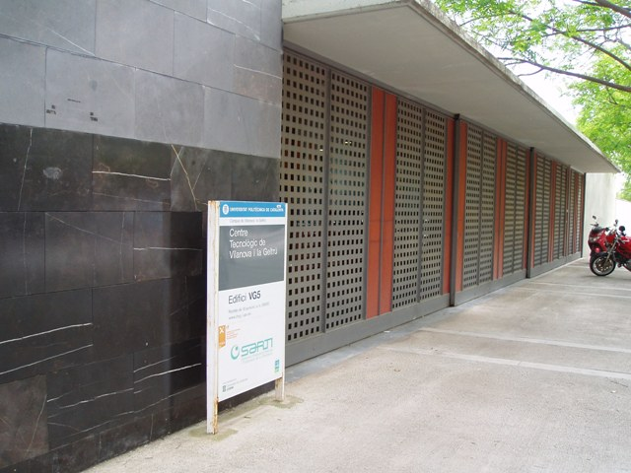
SARTI works in association with the Spanish National Research Council through its Institutes of Earth Sciences and Marine Sciences, is a member of the European Seas Observatory Network, and has been part of the Catalan network of technological innovation centres since 2001. Its activity combines academic research, technology transfer towards industry, and the operation of scientific instrumentation.
Figure 1: Host site: Centre Tecnologic de Vilanova I la geltru (CTVG), UPC Vilanova i la Geltrú campus

2.3 The OBSEA observatory
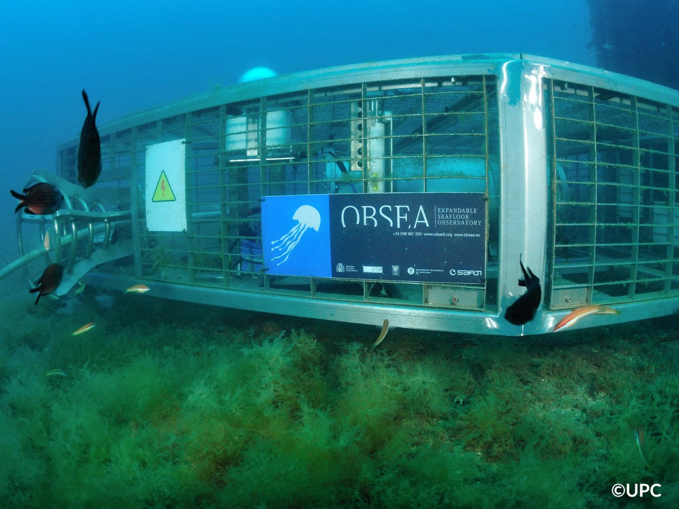
The most visible instrument operated by the group is OBSEA, an expandable cabled seafloor observatory deployed off the coast of Vilanova i la Geltrú. The observatory sits at a depth of twenty metres inside a fishing protected area and is connected to shore by a four-kilometre submarine cable. That cable delivers up to 3.6 kW of power to the seabed station and provides a one-gigabit-per-second communication link, which allows instruments to operate continuously and to transmit data in real time rather than storing them for later recovery. Its main goal is to observe the Posidonia, a marine plant of the Mediterranean sea which is really important for the sea ecosystem.
Figure 2 : OBSEA : Expandable Seafloor Observatory, SARTI UPC
The seabed station hosts oceanographic and biological instrumentation. A surface buoy moored forty metres away carries a weather station measuring wind speed, air temperature and atmospheric pressure, a satellite positioning receiver and a video camera. The whole installation is a permanent test bench for marine instrumentation as much as it is a scientific observatory, and a substantial part of the group's technical work consists in maintaining, extending and standardising the acquisition chains that feed it.
At SARTI almost everyone dives at OBSEA to collect, maintain, implement new devices underwater with a boat recently bought by UPC for this matter.

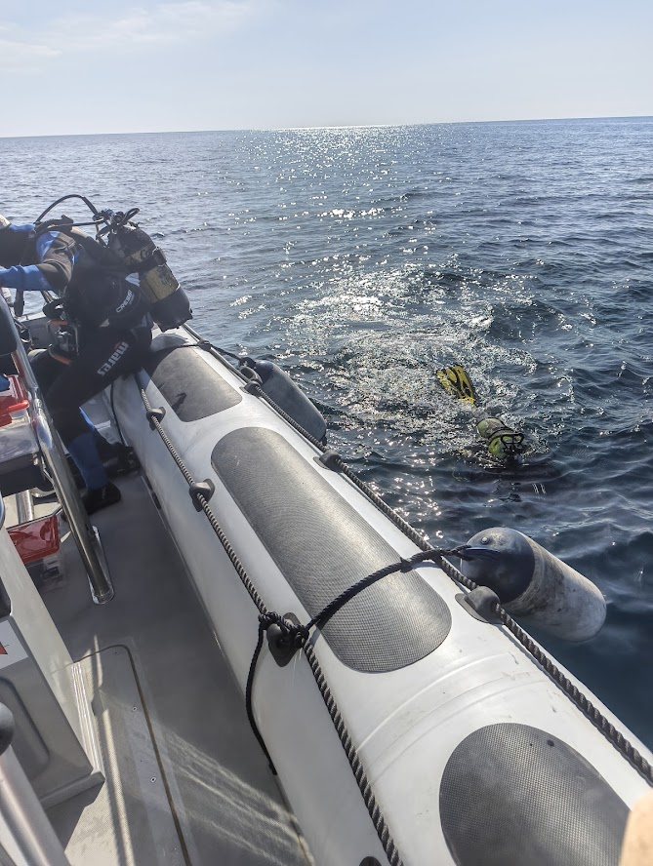
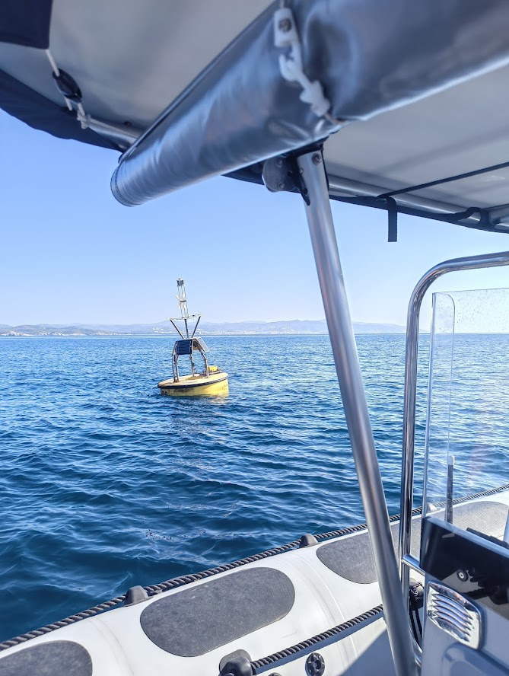
Figure 3 : OBSEA buoy and SARTI divers

2.4 Position of the internship within the group's activity
The project described in this report extends that acquisition activity from fixed instrumentation to a mobile platform. The observatory infrastructure already ingests, stores and publishes time series coming from fixed sensors; the vessels operated or used by the group produce comparable quantities but do not feed the same infrastructure. Bridging that gap was the object of the internship. The work was supervised by Joaquin DEL RIO, and the server-side deployment was carried out in coordination with the administrator responsible for the OBSEA computing infrastructure.
Table 1: Identification of the host organisation
Item | Value
Organisation | Universitat Politècnica de Catalunya (UPC) - SARTI research centre
Address | Rambla de l'Exposició 24, 08800 Vilanova i la Geltrú, Spain
Field of activity | Remote acquisition systems and information processing for marine and Earth sciences
Main infrastructure | OBSEA expandable seafloor observatory
Industrial tutor | Joaquin DEL RIO
Duration of the internship | 11 weeks, from 15/06/2026 to 18/09/2026 with a three weeks break
Working languages | English, Spanish, Catalan

3. Context

3.1 The existing installation
The starting point of the project is a working vessel equipped with a standard NMEA 2000 network.
Table 2: Devices connected to the vessel backbone
Device | Function | Quantities exposed on the bus
Sportnav SPO25F | GNSS receiver | position, speed and course over ground, satellite status
em-trak B921 | AIS class B transponder | own static data, position reports of surrounding traffic
SELVA outboard engine with DLC-Plus display | propulsion | engine speed, coolant temperature, operating hours, alarms
KTD-TM520 | depth and speed transducer | water depth below transducer, speed through water, water temperature

All of these devices are certified for the NMEA 2000 standard and coexist on a single backbone. The information they produce is displayed on board and then discarded: none of the devices stores a history, and none of them exposes an interface towards a shore network. Any subsequent use of the measurements, whether for scientific analysis, for fleet monitoring or for maintenance, is therefore impossible.

3.2 The shore infrastructure
On the shore side, the group operates a data infrastructure built on the OGC SensorThings API. This standard defines a normalised data model and a REST interface for the publication of sensor observations, and it is implemented here by FROST-Server, an open-source server backed by a PostgreSQL database with the PostGIS spatial extension. Choosing the same standard for the vessel data was a constraint of the project rather than an option: any measurement published in another format would have required a dedicated client, a dedicated storage schema and a dedicated maintenance effort.

3.3 The initial request
The request formulated at the beginning of the internship was to establish a continuous, automatic and standardised link between the two, namely to read the NMEA 2000 bus of the vessel, to decode the parameter groups carrying the quantities of interest, and to insert the corresponding observations into the existing database, in real time whenever network coverage allows. Two secondary requirements were expressed: the acquisition must not disturb the operation of the existing navigation devices in any way, and the crew must retain a local view of the acquired data even when the shore link is unavailable.

3.4 Social responsibility and sustainable development
The host laboratory is a public research centre attached to a university, so its social responsibility framework is that of the academic sector rather than that of a commercial company. Its equality and inclusion policy is defined at university level: UPC publishes an equality plan and operates a dedicated unit responsible for gender equality and for the accommodation of students and staff with disabilities. Within the research group, the working languages and the composition of the teams reflect a strong international mobility, and the reception of interns from foreign institutions is a routine part of the group's activity. The internship itself, carried out under a European mobility framework, is a concrete instance of that policy.
The environmental dimension is more directly connected to the scientific object of the laboratory. The group's activity consists in observing the coastal marine environment, and the OBSEA observatory is deployed inside a protected fishing area whose ecosystem it monitors continuously. The prioritised axis is therefore the production of environmental knowledge rather than the reduction of an industrial footprint, which is intrinsically small for a laboratory of this size. The choice of a cabled observatory is itself a sustainability decision: powering instruments from shore avoids the periodic replacement of battery packs at sea and the associated vessel movements, and it removes a recurrent source of waste in a protected area.
The work carried out during the internship contributes to that axis in three measurable ways. First, it increases the observational coverage of the coastal zone at no additional hardware cost, since the sensors being exploited are already installed and already powered on the vessel for navigation purposes. The marginal energy cost of the acquisition chain is limited to that of the acquisition node itself, of the order of one watt, against several hundred watts for the propulsion and the navigation electronics. Second, it makes engine data available, which opens the way to a quantified analysis of fuel consumption as a function of speed and sea state, and therefore to an operational reduction of emissions. Third, publishing the observations through an open standard rather than a proprietary format extends the useful lifetime of the data and allows their reuse by other teams, which is a form of sobriety applied to scientific information: a measurement that can be found and interpreted ten years later does not have to be acquired twice.
Several technical decisions described in the following chapters were taken with those considerations in mind. The node was designed to listen to the bus without drawing power from it and without transmitting on it, which protects the existing installation and avoids any duplication of sensors. Standard, widely available and inexpensive components were preferred to a custom design, which reduces the environmental cost of manufacturing and makes repair and replacement possible without a specific supply chain. The publication format was aligned with an existing open standard rather than defined ad hoc, which avoids the future rewriting of clients and databases. These choices connect the project to the United Nations sustainable development goals 9, industry, innovation and infrastructure, 13, climate action, and 14, life below water, the last of which is the explicit object of the observatory.
The main limitation identified during this analysis concerns the end of life of the electronics and the dependence on a mobile network operator for the transmission. Neither point was addressed within the eleven weeks. A recommendation for the continuation of the project is to specify the acquisition node as a repairable module with a documented bill of materials, and to evaluate a store-and-forward mode that would allow the vessel to operate outside network coverage without loss of data, which would reduce both the volume of transmitted data and the energy spent on the radio link.
On a personal level, this experience situated engineering work inside a scientific and environmental purpose that is explicit rather than implied. The engineer's role in ecological and digital transitions appears here as that of an intermediary: the measurement exists, the science exists, and what is missing is the chain that makes one available to the other. That observation is a durable one and is intended to guide subsequent professional choices.

4. Technical objectives and specification

4.1 Functional requirements
The initial request was translated into a set of numbered requirements at the end of the second week, after the first bench experiments had established what the bus could actually deliver. The requirements are stated in verifiable form, so that each of them can be associated with an acceptance test in Chapter 5.
Table 3: Functional requirements
Ref. | Requirement | Verification
F1 | Receive and decode the parameter groups carrying position, course, speed, heading, water depth and engine parameters | Comparison of the decoded value with the reading of the corresponding on-board display
F2 | Decode the position reports of surrounding AIS traffic | Comparison with an independent AIS receiver
F3 | Publish each acquired quantity to the shore database as a normalised observation | Query of the database over its REST interface
F4 | Timestamp every observation with an absolute time reference | Inspection of the phenomenonTime field of the stored observations
F5 | Serve a local web dashboard displaying the current values | Access from a browser connected to the on-board network
F6 | Resume operation automatically after a loss of the radio link or a power cycle | Interruption test on the link and on the supply

Table 4: Non-functional requirements
Ref. | Requirement | Target value
N1 | Publication period per quantity | 1 s
N2 | Electrical load presented to the NMEA 2000 backbone | 12V external battery to power the NMEA network
N3 | Effect on the existing devices | strictly none, reception only
N4 | Continuous operation without manual intervention | ≥ 24 h
N5 | Compliance of the published data with the OGC SensorThings API | version 1.1
N6 | Transport security between vessel and server | encrypted channel, key-based server administration

4.2 Boundaries of the study
Three points were explicitly excluded from the scope at the start of the project, and are recalled here because they bound the interpretation of the results. The node does not transmit on the NMEA 2000 bus, so no address claiming procedure and no device certification were required. The long-term storage policy, the retention period and the backup of the database are the responsibility of the infrastructure administrator and were not redefined. Finally, the scientific exploitation of the collected data, that is to say their analysis, was not part of the internship: the objective was to make the data exist, to make them accessible and to make them interpretable.

5. Technical development

5.1 Approach and phases of the work
The work was organised around one principle: understand and decode the NMEA 2000 network in the laboratory first, and use the vessel only to confirm the results. The vessel is not always available, the trip to the harbour takes time, and a test on board gives little room for trial and error. A simulation bench made of two ESP32-S3 boards was therefore built at the start of the internship, and almost all the development and debugging was done on it. The vessel was visited only a few times, to check on the real network what had been validated on the bench.
The project then grew in three phases. Each phase was requested by the tutor once the previous one was working, so the scope of the work was defined progressively.
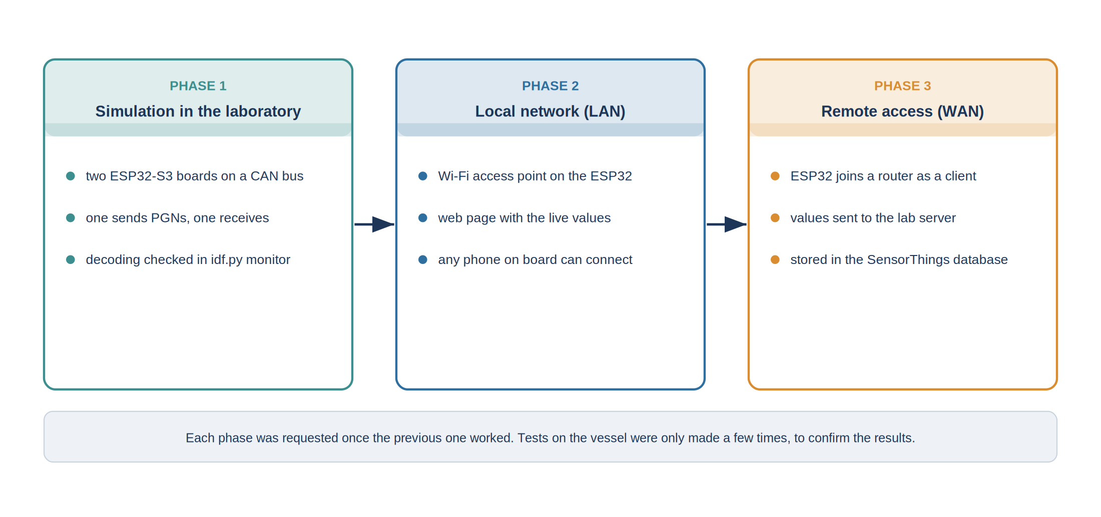
Figure 4: The three phases of the project, from the simulation bench to the remote database
In the first phase, the goal was to receive and decode the NMEA 2000 frames and to check the decoded values in the ESP-IDF monitor. In the second phase, a web page was added to display the values more clearly: the ESP32 creates its own Wi-Fi access point, and any phone connected to it can open the page. This is the local network part of the project, or LAN. In the third phase, the values had to leave the vessel: the ESP32 joins a router as a client and sends the values to the server of the laboratory, where they are stored in a database. This is the remote part, or WAN, added on top of the LAN part already working.
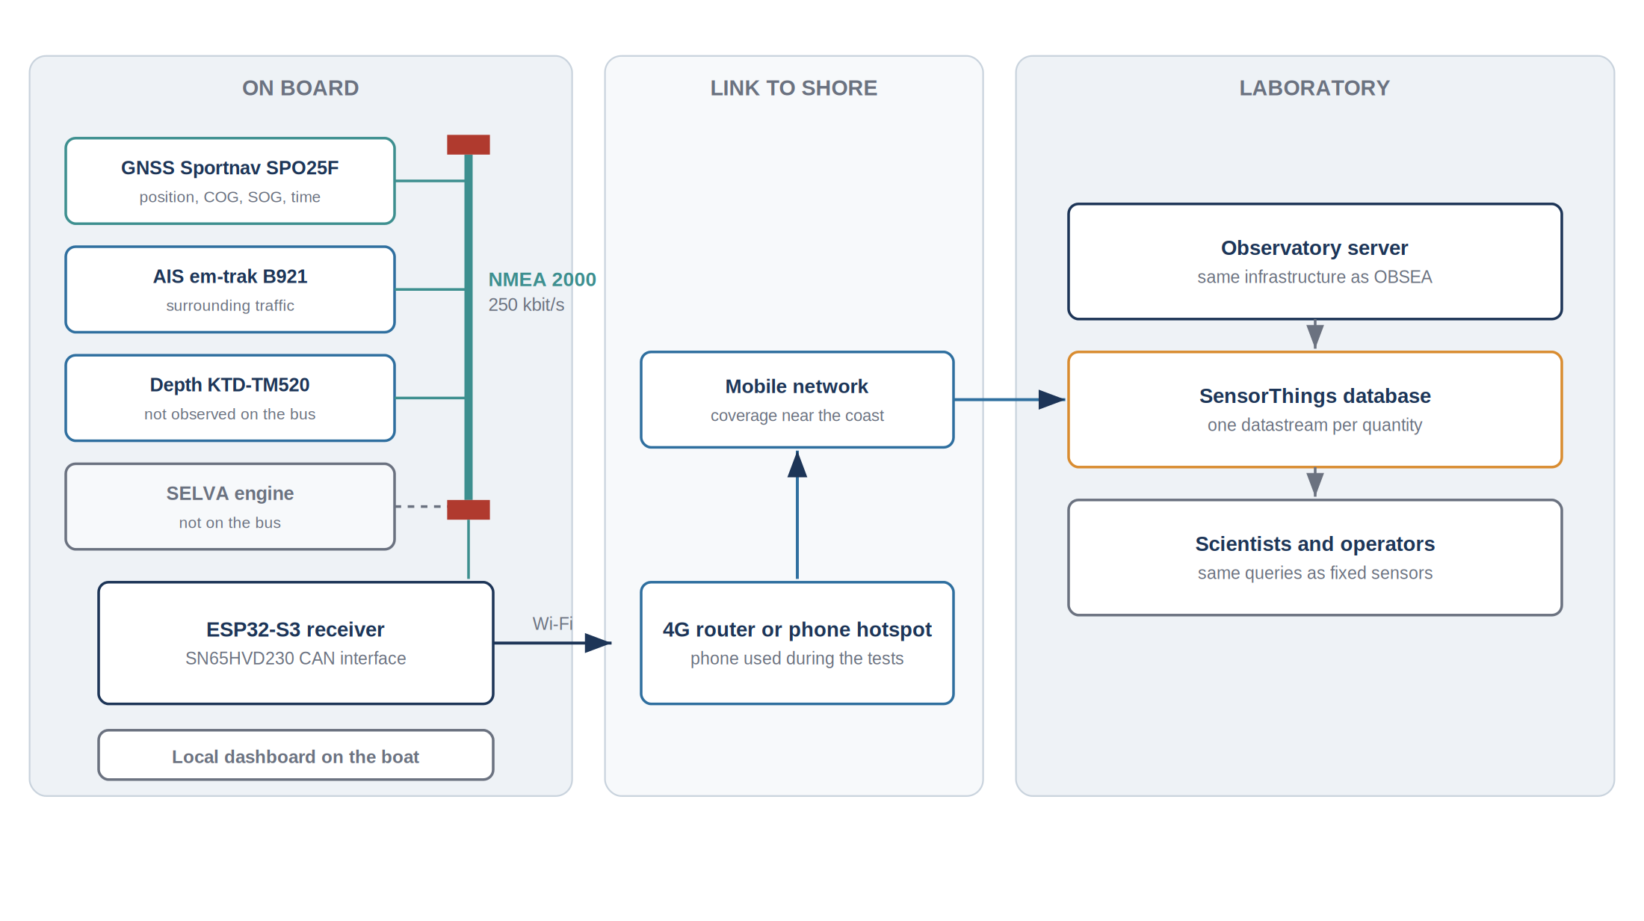
Figure 5: Final acquisition chain, from the vessel equipment to the laboratory

5.2 The NMEA 2000 network

5.2.1 Principle
NMEA 2000 is the standard network for marine electronics, published by the National Marine Electronics Association. It connects the navigation equipment of a vessel, such as the GPS receiver, the AIS transponder, the depth sounder or the engine, on a single cable, so that every device can share its data with all the others. It replaces the older NMEA 0183 standard, in which each device sending data had to be wired to its listeners through a separate serial link.
Table 5: Comparison of NMEA 0183 and NMEA 2000
Criterion | NMEA 0183 | NMEA 2000
Topology | one talker, several listeners, point to point | all devices on a single bus
Speed | 4 800 bit/s, 38 400 bit/s for AIS | 250 kbit/s
Data format | ASCII text sentences | binary messages identified by a PGN
Wiring | one cable for each link | one backbone with drop cables
Power | each device has its own supply | the bus can supply small devices
Adding a device | new cables and configuration | plug in a T-connector

The network is built on CAN, the bus developed for cars, and its message layer comes from the ISO 11783 standard of agricultural machinery, itself derived from the SAE J1939 standard of trucks. That origin explains why the network is robust against electrical noise, which is important on a vessel, close to an engine and a VHF radio.

5.2.2 Physical layer and wiring
The network is a single line. A main cable, the backbone, runs through the vessel and is closed at each end by a 120-ohm terminating resistor. Each device is connected to the backbone with a T-connector and a short drop cable. The terminators absorb the signal at the ends of the line and prevent reflections. A simple check follows from this: with the network switched off, the resistance between CAN H and CAN L must be close to 60 ohms, the two 120-ohm resistors being in parallel.
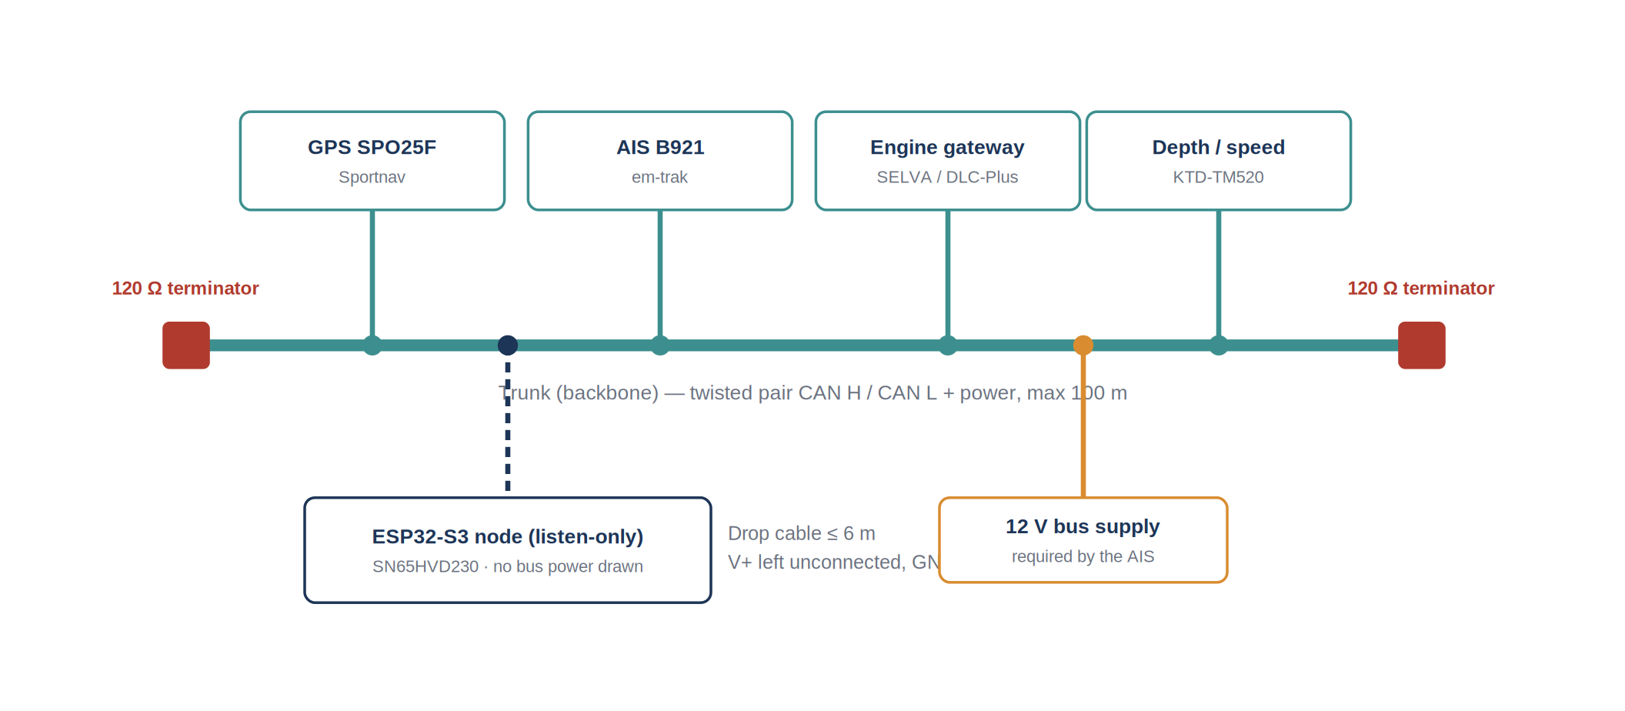
Figure 6: Backbone of the vessel, devices connected and position of the ESP32 receiver
Table 6: Main limits of the physical layer
Parameter | Limit
Bit rate | 250 kbit/s
Backbone length | 100 m with standard cable
Length of one drop cable | 6 m
Total length of all drop cables | 78 m
Number of connections | 50
Supply voltage on the bus | 9 to 16 V

The backbone carries four conductors and a shield: CAN H and CAN L for the data, and a power pair that can supply the small devices from the 12 V network of the vessel. The connectors are circular M12 connectors with five pins, called micro-C, which are sealed and screwed to resist water and vibration.
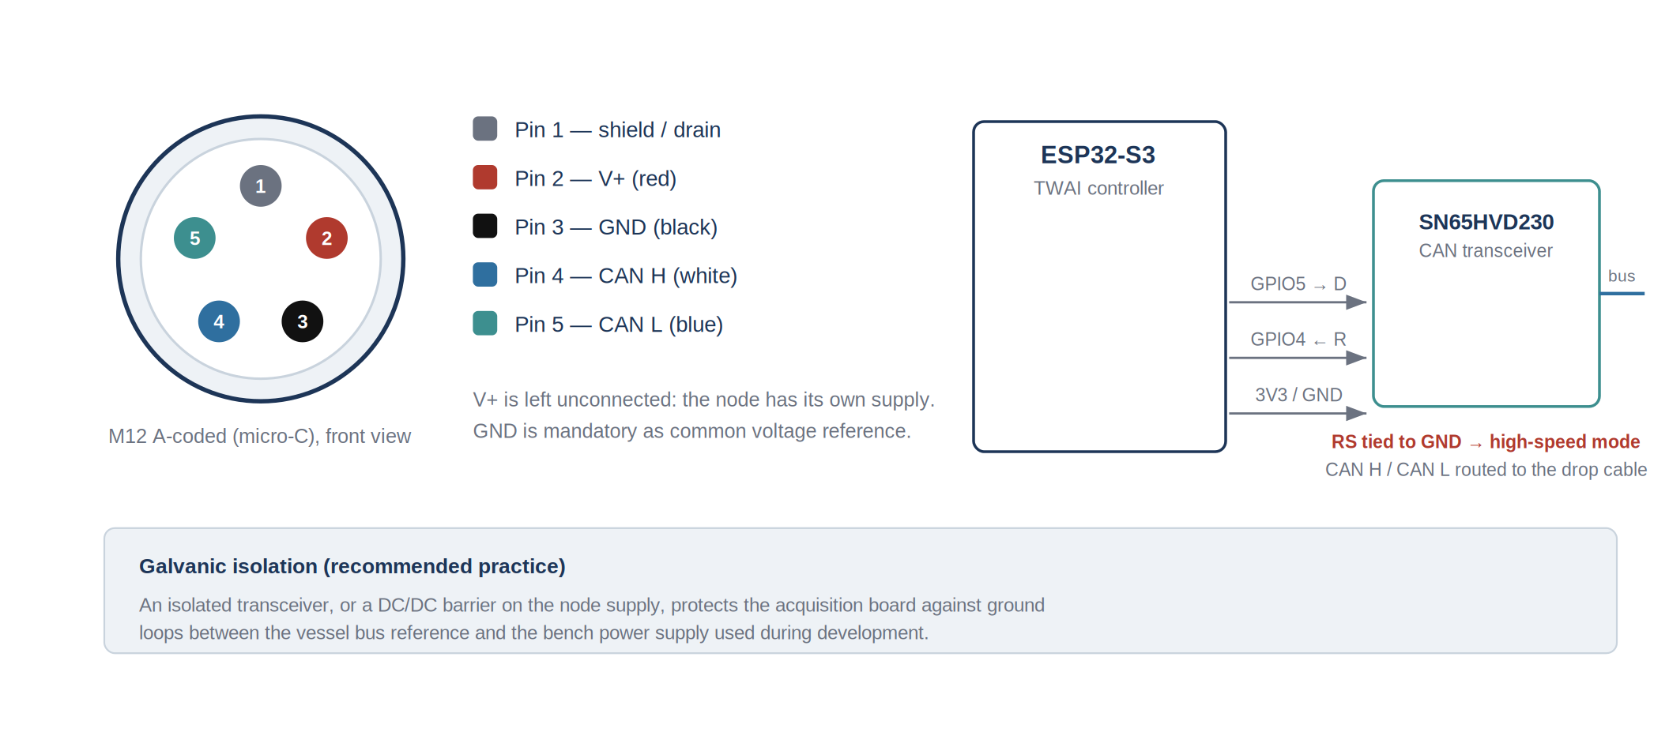
Figure 5: M12 five-pin pinout and connection of the ESP32 board to the network
Two points of the wiring were important for the ESP32 board. The power conductor, pin 2, was not connected, because the board has its own supply. The ground, pin 3, was connected, because the transceiver compares CAN H and CAN L with its own ground; without a ground shared with the network, the signals can leave the input range of the circuit and the reception becomes intermittent. The pinout was always checked with a multimeter before connecting anything, because an inversion of CAN H and CAN L produces no error message: the board simply receives nothing.

5.2.3 Structure of a message
Every message on the bus is a CAN frame made of an identifier of 29 bits and up to 8 bytes of data. The identifier contains three pieces of information. The priority tells which message wins when two devices transmit at the same time. The Parameter Group Number, or PGN, tells what the message contains, for example a position or a speed. The source address tells which device sent it.
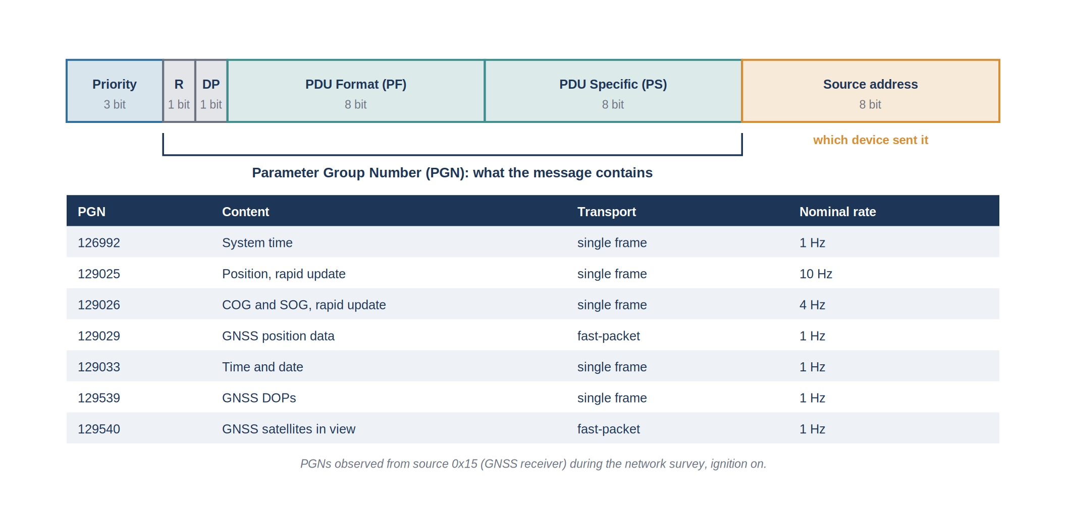
Figure 6: Structure of the 29-bit identifier and PGNs sent by the GPS receiver of the vessel
The PGN is the key to reading the network. Each PGN has a fixed layout: the standard defines which byte holds which value, with which unit and which resolution. A receiver that knows the layout of a PGN can therefore read the data of any certified device, whatever its brand.

5.2.4 Single-frame and fast-packet messages
Eight bytes are enough for a position or a speed, but not for a complete GPS fix or an AIS report. Longer messages are cut into several frames, a mechanism called fast-packet. The first frame contains a sequence counter, the total length of the message and 6 bytes of data; the next frames contain the counter and 7 bytes of data each. The receiver must put the pieces back together in the right order before decoding the message.
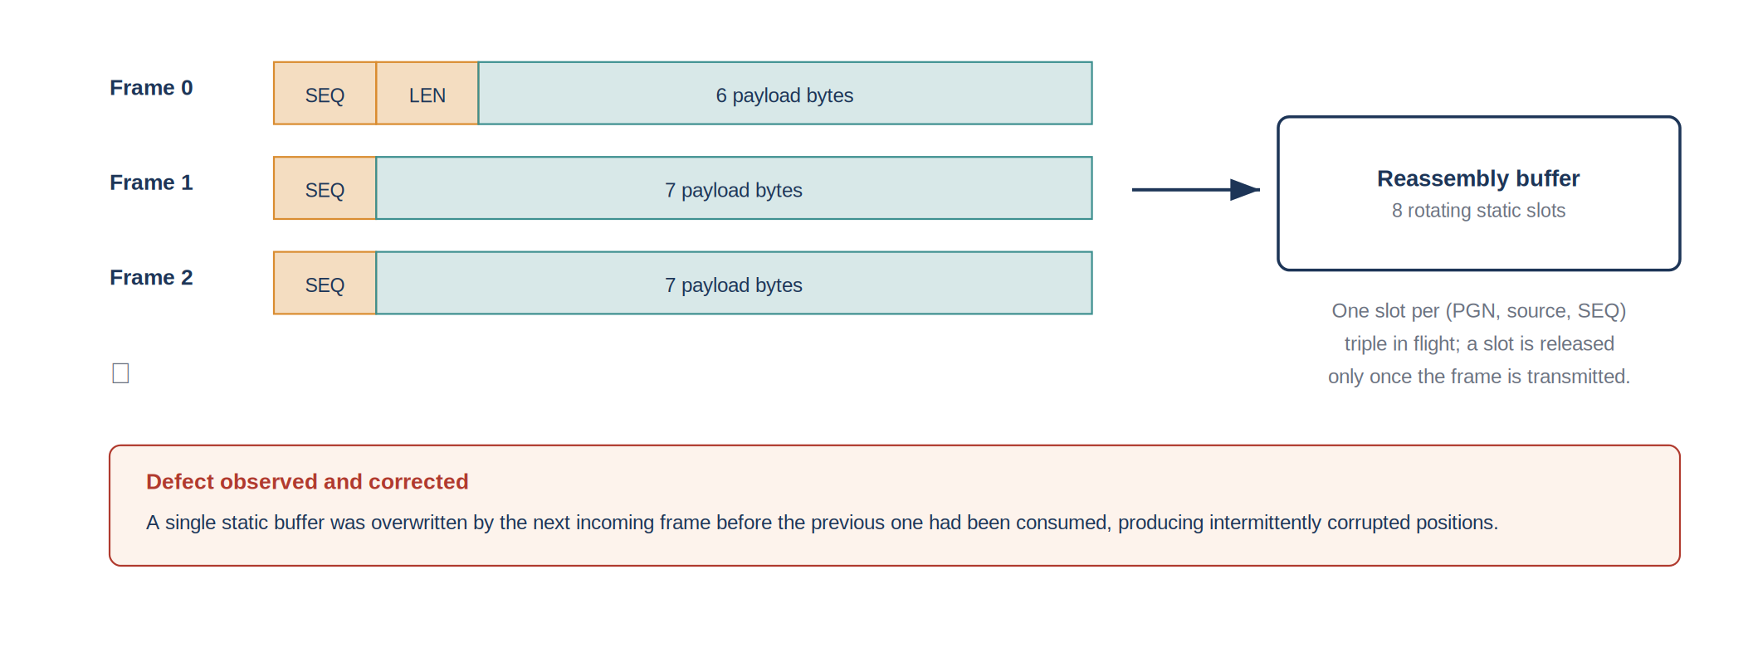
Figure 7: Transport of a message longer than 8 bytes in several frames (fast-packet)

5.2.5 Network management
Besides the navigation data, the devices exchange management messages. At power-on, each device claims an address with PGN 60928 and announces a unique name that contains its manufacturer and its function. On request, it describes itself with PGN 126996, product information, which gives its model and software version, and lists the PGNs it sends with PGN 126464. Because an address can change from one power-on to the next, the source address alone is not a permanent identifier of a device; the name and the product information are. These management messages were not used in this project, but they are the basis of the automatic device detection proposed in Section 5.10.

5.2.6 Devices of the vessel and their PGNs
The vessel carries a GPS receiver, an AIS transponder, a depth and speed transducer and an outboard engine with its display at the helm. Each NMEA 2000 device is expected to send a known set of PGNs, which gives a list of what the receiver should find on the network.
Table 7: Devices of the vessel, expected PGNs and PGNs actually received
Device | Function | Expected PGNs | Received on the network
Sportnav SPO25F | GPS receiver | 129025, 129026, 129029, 129033, 126992, 129539, 129540 | all of them, source address 0x15
em-trak B921 | AIS class B transponder | 129038, 129039 and static data | only when the backbone is supplied with 12 V
KTD-TM520 | depth and speed transducer | 128267, 128259 | Observed on 0x15
SELVA outboard with DLC-Plus display | engine and engine display | 127488, 127489 | never, the engine is not connected to the network

The difference between the two last columns is one of the main results of the tests on board, described in Section 5.7.

5.3 The ESP32-S3 board and its CAN interface
The receiver is an ESP32-S3 development board. This microcontroller was chosen because it contains a CAN controller, called TWAI by its manufacturer Espressif, and a Wi-Fi radio, which covers both sides of the project: the vessel network on one side and the local and remote network on the other.
The CAN controller cannot be connected directly to the bus, because the voltage levels of the bus are different from those of the microcontroller. An SN65HVD230 transceiver converts the logic signals of the ESP32 into the differential signals of the bus, and back. Its RS pin, which selects the speed mode, must be connected to the ground to work at 250 kbit/s; left unconnected, it puts the transceiver in a standby mode in which nothing is received.
Table 8: Connections of the ESP32 board
Signal | ESP32-S3 | SN65HVD230 | NMEA 2000 (M12)
Transmission | GPIO5 | D (TX) | -
Reception | GPIO4 | R (RX) | -
Supply | 3.3 V | VCC | not connected (pin 2)
Ground | GND | GND | pin 3
Speed mode | - | RS to GND | -
Data | - | CAN H / CAN L | pin 4 / pin 5

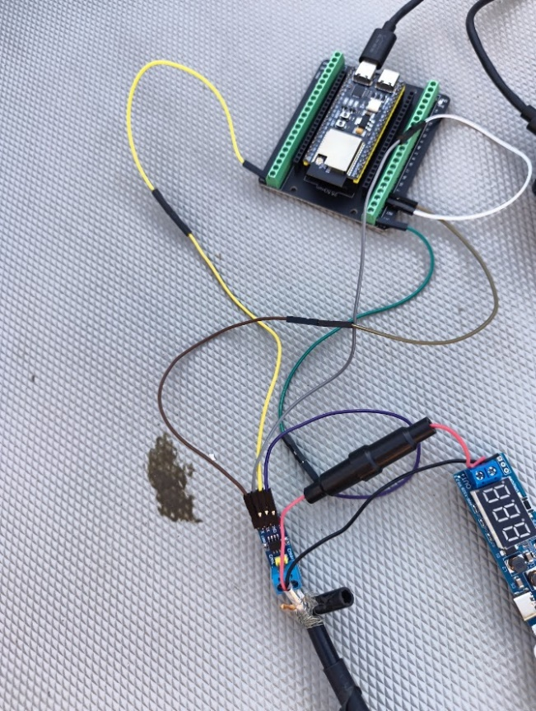
The firmware was developed in Visual Studio Code with the ESP-IDF framework, version 5.5.4, and the open-source NMEA 2000 library written by T. Lappalainen, which handles the reception of the frames and the reassembly of fast-packet messages. Every modification followed the same cycle with the idf.py tool: build the firmware, flash it into the board through the USB cable, then open idf.py monitor to read what the board prints. The USB cable also supplied the board, which, as explained in Section 5.7, was also the case on the vessel.
Figure 8: ESP32-S3 board and CAN transceiver used as receiver

5.4 Simulation bench with two ESP32 boards

5.4.1 Principle
To work without going to the vessel, a small NMEA 2000 network was built on the desk with two ESP32-S3 boards. The first board plays the role of the vessel equipment: it sends the PGNs expected on board, with values chosen in advance and at their normal rates. The second board is the receiver, with the same firmware that is later used on the vessel. The two boards are connected through their transceivers by a twisted pair, with a 120-ohm resistor at each end, exactly like a real backbone.
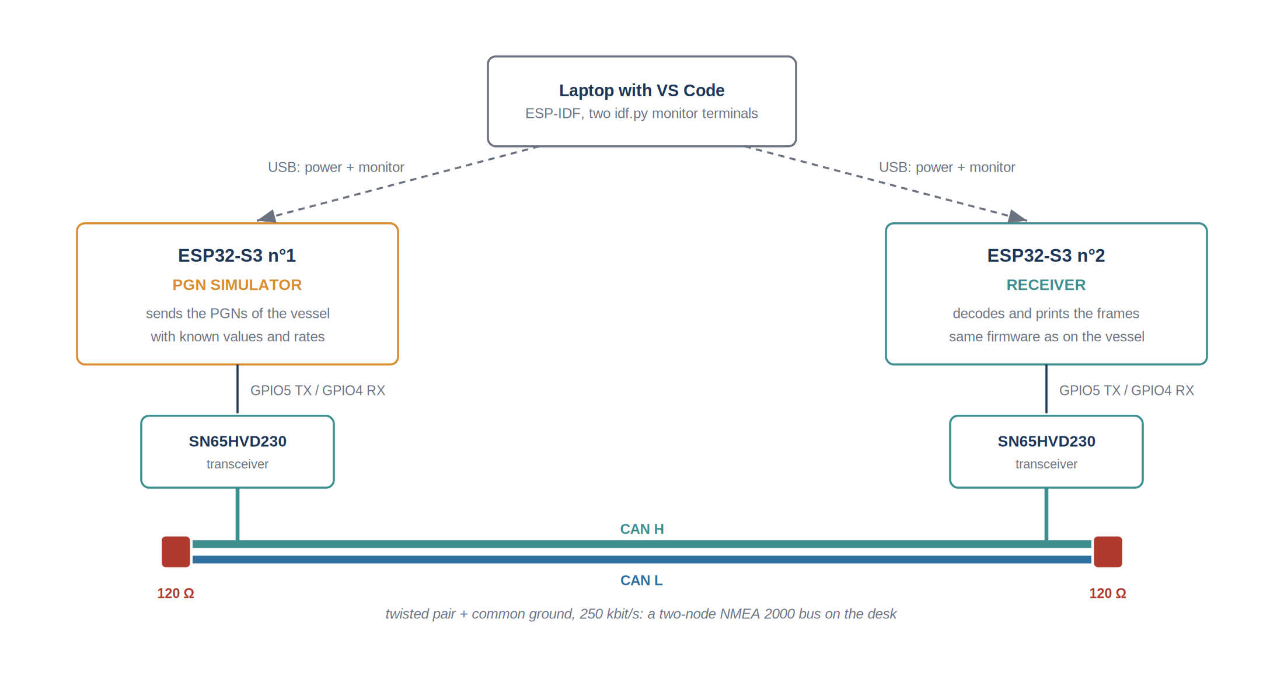
Figure 9: Simulation bench: one ESP32 sends PGNs, the other receives and decodes them
Both boards are connected to the laptop by USB, and each one has its own monitor window in VS Code. The frames sent by the simulator and the values decoded by the receiver can therefore be compared side by side, in real time. Since the simulator sends known values, any difference between the two windows points directly to a decoding error.
5.4.2 The three devices simulated

The simulator does not imitate a single device but the whole network of the vessel. It transmits under three different source addresses, so that the receiver sees three devices as it would on board: the GPS receiver at address 0x15, the AIS transponder at address 0x23 and the engine with its sensors at address 0x31. At start-up it sends one address claim, PGN 60928, for each of the three addresses, with a name built from a unique number and a manufacturer code, which is what a real device does when it joins the network.
This is the main advantage of the bench: the engine and the AIS, which could not be tested on the vessel because the engine is not connected to the network and the AIS only appears when the backbone is supplied, are always available on the desk. The decoding of their PGNs could therefore be written and validated even though the real vessel never produced them.

Table 9: Messages sent by the simulator
PGN | Source | Period | Simulated content
60928 Address claim | the three | at start-up | one name per simulated device
129025 Position, rapid update | GPS 0x15 | 100 ms | circle of 500 m radius around 41.3809 N, 2.1734 E, one turn in 120 s
127250 Vessel heading | GPS 0x15 | 100 ms | heading equal to the course of the circle
129026 COG and SOG | GPS 0x15 | 250 ms | course following the circle, speed 6.5 knots
129029 GNSS position data | GPS 0x15 | 1 s | same position, altitude 2 m, 11 satellites
129539 GNSS DOPs | GPS 0x15 | 1 s | HDOP 1.1, PDOP 1.5, TDOP 1.0
129033 Time and date | GPS 0x15 | 1 s | clock of the simulator
126992 System time | GPS 0x15 | 1 s | same clock
127488 Engine, rapid update | engine 0x31 | 100 ms | engine speed between 800 and 3500 rpm
127489 Engine, dynamic | engine 0x31 | 500 ms | coolant 82 ± 8 °C, oil 90 ± 5 °C, oil pressure 3.5 ± 0.5 bar
127505 Fluid level | engine 0x31 | 1 s | fuel tank slowly emptying from 75 %
127508 Battery status | engine 0x31 | 1 s | voltage 13.8 ± 0.3 V
128267 Water depth | engine 0x31 | 1 s | depth 12.5 ± 2 m
128259 Speed through the water | engine 0x31 | 1 s | 6.2 ± 0.8 knots
130310 Environmental parameters | engine 0x31 | 1 s | water temperature 18.5 ± 1 °C
129039 AIS class B position | AIS 0x23 | 3 s | four vessels around Barcelona, one of them at anchor
129809 / 129810 AIS class B static data | AIS 0x23 | 30 s | call sign and name of one vessel in turn

The values are not fixed but follow simple laws of time, so that the receiver can be checked on moving data. The simulated vessel turns on a circle of 500 metres of radius, which makes the position, the course and the heading change continuously, and the engine speed, the temperatures and the depth follow slow sine waves. The four AIS targets move along their own course at their own speed between two reports, except one which is declared at anchor and therefore does not move.

5.4.3 Advantages and limits of the bench
The bench made the development much faster. A modification could be tested in a minute instead of a trip to the harbour, the same test could be repeated as many times as needed, and a fault could be reproduced on demand. It also made it possible to test situations that are rare on board, such as a burst of messages or a wrong value, by changing the simulator.
The bench also has limits, and they explain why the tests on board were still necessary. On a CAN bus, a frame must be acknowledged by at least one other node; with only two boards, the receiver provides that acknowledgement, which is not the situation of a real network with several devices. The simulator only sends well-formed messages, at regular rates, while real devices send bursts of messages and have their own behaviour. Some facts about the vessel cannot be simulated at all: which devices are really connected, and in which conditions they transmit. Those facts were discovered on board, as described in Section 5.7.
Table 10: What the bench can and cannot reproduce
Aspect | On the simulation bench | On the vessel
Wiring, transceiver, terminators | reproduced exactly | same wiring
Layout of the PGNs and decoding | reproduced exactly, with known values | real values, unknown in advance
Rates of the messages | regular, as programmed | real rates, with bursts
Devices present on the network | only those programmed in the simulator | only those really connected
Power of the backbone | not needed | decides which devices are active
Repeating a test | unlimited, in a minute | a few visits only

5.5 Decoding, processing and display

5.5.1 Processing of a frame
Each frame received goes through the same chain, whatever the phase of the project. The identifier is read to find the PGN, the source and the priority. If the PGN is a fast-packet message, the frame is stored until all the pieces have arrived. The complete message is then decoded field by field: each field is read from its bytes and multiplied by its resolution to obtain a value in physical units. A last check removes the values marked as not available: the standard uses the largest possible number of a field to say that the device has no value, and that number must never be taken for a real measurement. The last valid value of each quantity is then kept, with the time of its reception.
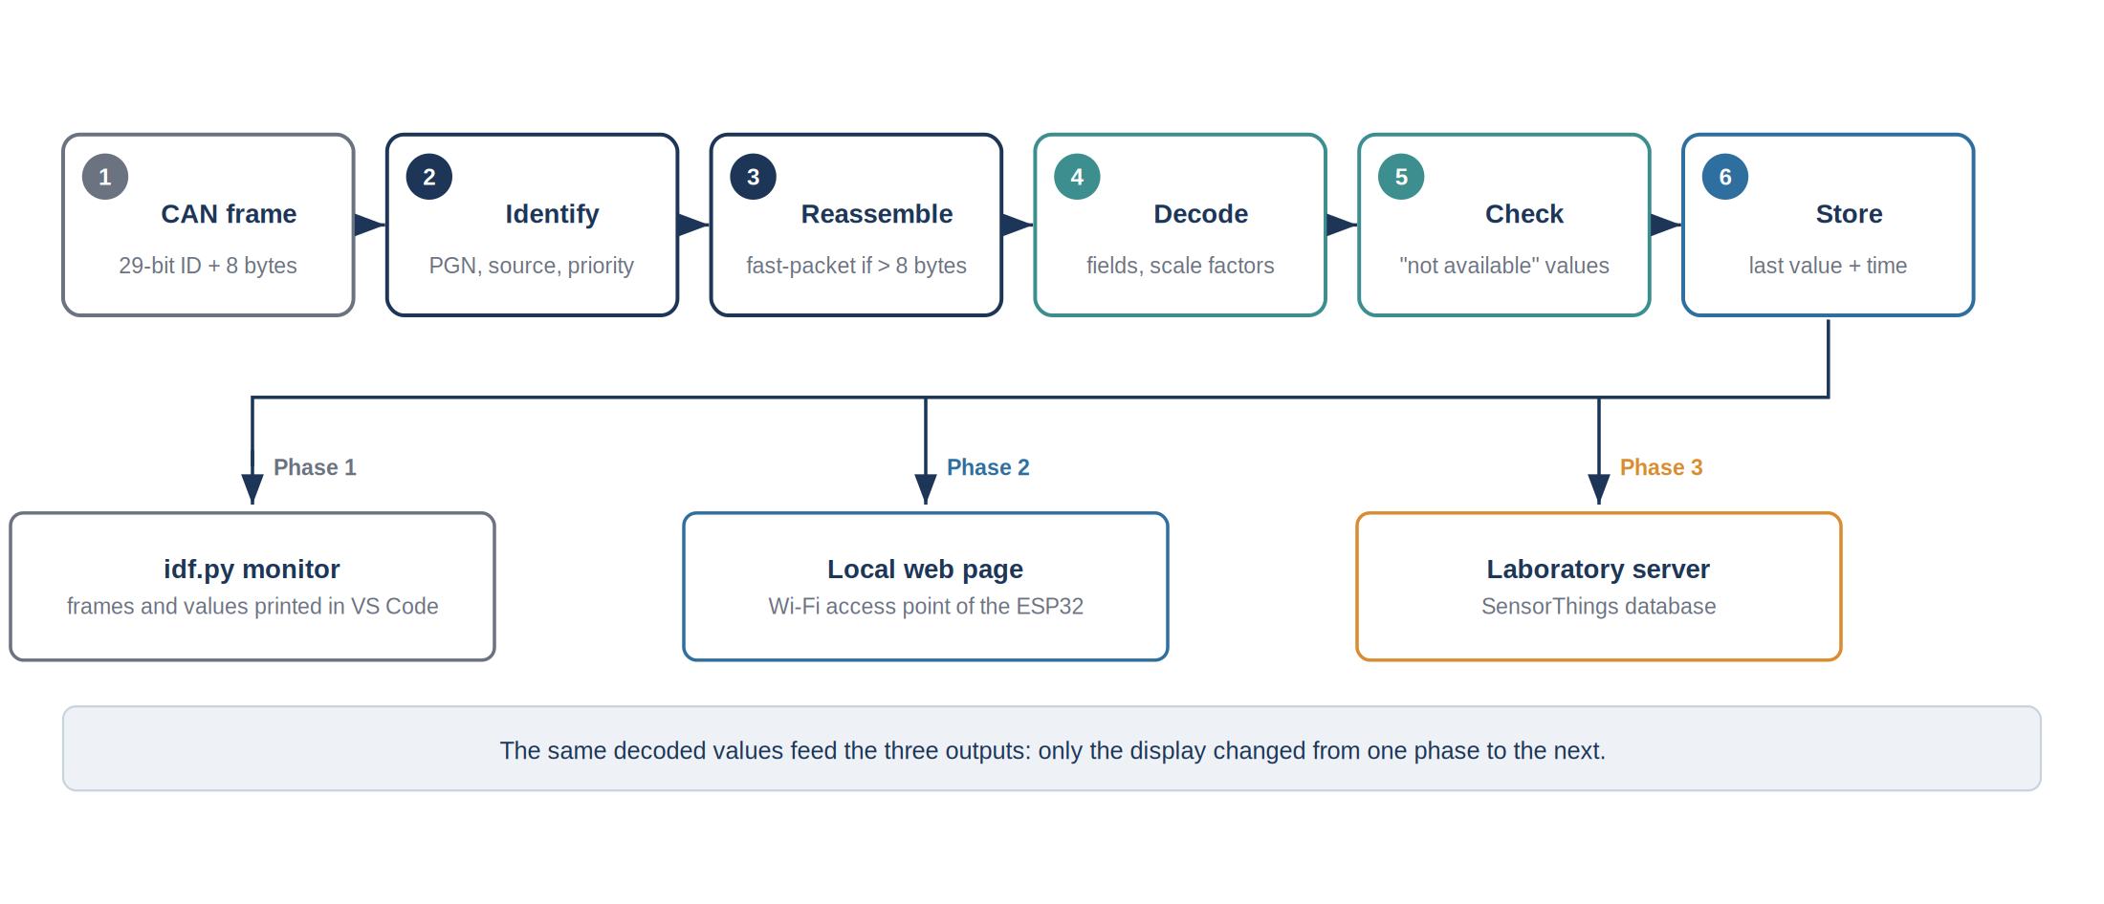
Figure 10: Processing of a frame and the three outputs used during the project
The same decoded values were used for the three outputs of the project: the monitor in phase 1, the local web page in phase 2 and the laboratory server in phase 3. Only the display changed from one phase to the next.

5.5.2 Reading the frames in idf.py monitor
In phase 1, the only way to see the result was the monitor of ESP-IDF, opened in VS Code with idf.py monitor. The receiver prints one line for each frame received, with its PGN, its source address, its priority, its length and its raw bytes in hexadecimal, followed by the decoded values. The example below shows the format of those lines for the main PGNs of the GPS receiver.
I (370177) NMEA_AP: RX PGN=129025 src=0x15 data=F6E59018461B0801
I (370187) NMEA_AP: RX PGN=128267 src=0x15 data=65BC010000FD7FFF
I (370207) NMEA_AP: RX COG=192.9 SOG=0.00kn
I (370217) NMEA_AP: RX PGN=129025 src=0x15 data=F6E59018461B0801
I (370317) NMEA_AP: RX PGN=129025 src=0x15 data=F6E59018461B0801
I (370417) NMEA_AP: RX PGN=129025 src=0x15 data=F6E59018461B0801
I (370467) NMEA_AP: RX COG=192.9 SOG=0.00kn

The data above is a sample of real data aquired on the boat with the monitor on Vscode. You can see the PGN, its address, its value and the decoded value bellow which is the COG and SOG in this sample.
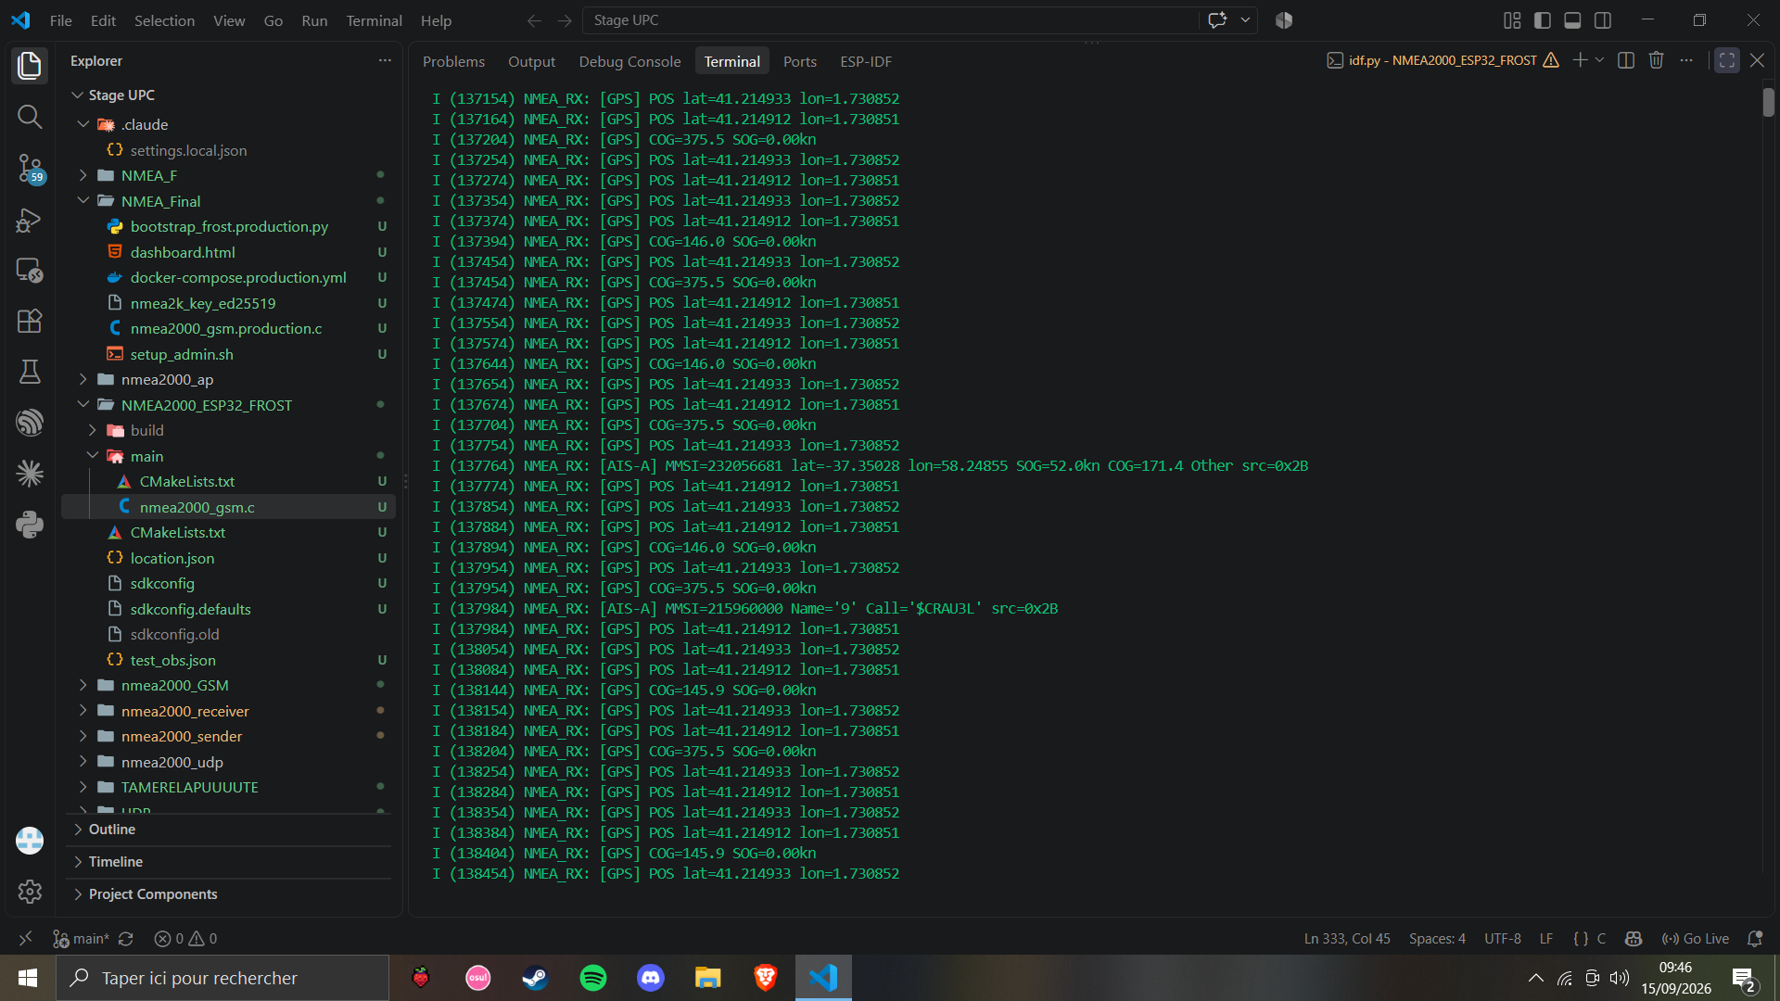
Figure 11: Frames and decoded values displayed in the ESP-IDF monitor

5.5.3 Reading a fast-packet message in the monitor
The multi-frame messages can also be followed in the monitor. The example below shows the 7 frames of one PGN 129029 message. The first byte of each frame is the sequence byte: its upper three bits are the counter of the message, here 2, and its lower five bits are the number of the frame, from 0 to 6. The second byte of frame 0, 2B, gives the total length of the message, 43 bytes.
I (368997) NMEA_AP: RX PGN=126992 src=0x15 data=63F0A15040675E18
I (368997) NMEA_AP: RX PGN=129025 src=0x15 data=F6E590184B1B0801
I (368997) NMEA_AP: RX PGN=129540 src=0x15 data=E0CF64FF1101E728
I (369007) NMEA_AP: RX PGN=129540 src=0x15 data=E12D44100E000000
I (369007) NMEA_AP: RX PGN=129540 src=0x15 data=E200F4028B18CF51
I (369007) NMEA_AP: RX PGN=129540 src=0x15 data=E3740E00000000F4
I (369017) NMEA_AP: RX PGN=129540 src=0x15 data=E403673022060410
I (369027) NMEA_AP: RX PGN=129540 src=0x15 data=E500000000F40468
I (369027) NMEA_AP: RX PGN=129540 src=0x15 data=E621B77A800C0000
I (369037) NMEA_AP: RX PGN=129540 src=0x15 data=E70000F406220642
I (369037) NMEA_AP: RX PGN=129540 src=0x15 data=E8CFB80B00000000
I (369047) NMEA_AP: RX PGN=129540 src=0x15 data=E9F4080000000014
I (369047) NMEA_AP: RX PGN=129540 src=0x15 data=EA0500000000F109
I (369057) NMEA_AP: RX PGN=129540 src=0x15 data=EBA20DB789800C00
I (369067) NMEA_AP: RX PGN=129540 src=0x15 data=EC000000F411C522
I (369067) NMEA_AP: RX PGN=129540 src=0x15 data=ED93BF6810000000
I (369077) NMEA_AP: RX PGN=129540 src=0x15 data=EE00F413B91164D5
I (369077) NMEA_AP: RX PGN=129540 src=0x15 data=EF100E00000000F4
I (369087) NMEA_AP: RX PGN=129540 src=0x15 data=F01674059FB21C0C
I (369087) NMEA_AP: RX PGN=129540 src=0x15 data=F100000000F41CDC
I (369097) NMEA_AP: RX PGN=129540 src=0x15 data=F2082D26100E0000
I (369107) NMEA_AP: RX PGN=129540 src=0x15 data=F30000F41FE80AF3
I (369107) NMEA_AP: RX PGN=129540 src=0x15 data=F439800C00000000
I (369117) NMEA_AP: RX PGN=129540 src=0x15 data=F5F4220000000048
I (369117) NMEA_AP: RX PGN=129540 src=0x15 data=F60D00000000F131
I (369127) NMEA_AP: RX PGN=129540 src=0x15 data=F700000000A00F00
I (369127) NMEA_AP: RX PGN=129540 src=0x15 data=F8000000F1310000
I (369137) NMEA_AP: RX PGN=129540 src=0x15 data=F90000A00F000000
I (369147) NMEA_AP: RX PGN=129540 src=0x15 data=FA00F13100000000
I (369147) NMEA_AP: RX PGN=129540 src=0x15 data=FB740E00000000F1
I (369157) NMEA_AP: RX PGN=129540 src=0x15 data=FCB9E728DC263C0F
I (369157) NMEA_AP: RX PGN=129540 src=0x15 data=FD00000000F4FFFF
I (369167) NMEA_AP: RX POS lat=485497385688.9716797 lon=-429.0937349

Once the 43 bytes are put back together, the message is decoded like any other: after the sequence identifier come the date, 20 648 days after 1 January 1970, that is 14 July 2026, and the time, then the latitude and longitude as 64-bit integers with a resolution of 1e-16 degree, the altitude, the type of fix, the number of satellites and the dilution of precision. The last frame is completed with FF bytes, which carry no data. If one of the 7 frames is missing, the counter shows it and the whole message is rejected. [Illustrative values; to be replaced by a real capture.]

5.5.4 Frequencies of the PGNs
Each PGN is sent at its own rate, defined by the standard according to how fast the quantity changes. The position is sent ten times per second, because it is used for navigation in real time; the time and the quality of the fix only once per second. The rates were checked in the monitor by counting the lines of each PGN over a given time.
Table 11: Frequencies of the PGNs sent by the GPS receiver
PGN | Content | Transport | Nominal period | Frames per second | Observed on board
129025 | Position, rapid update | single frame | 100 ms | 10 | ~3
129026 | COG and SOG, rapid update | single frame | 250 ms | 4 | ~1
129029 | GNSS position data | fast-packet, 7 frames | 1 s | 7 | ~8
129033 | Time and date | single frame | 1 s | 1 | 1 per second
126992 | System time | single frame | 1 s | 1 | 1 per second
129539 | GNSS DOPs | single frame | 1 s | 1 | 1 per second
129540 | Satellites in view | fast-packet, about 20 frames | 1 s | about 20 | ~20

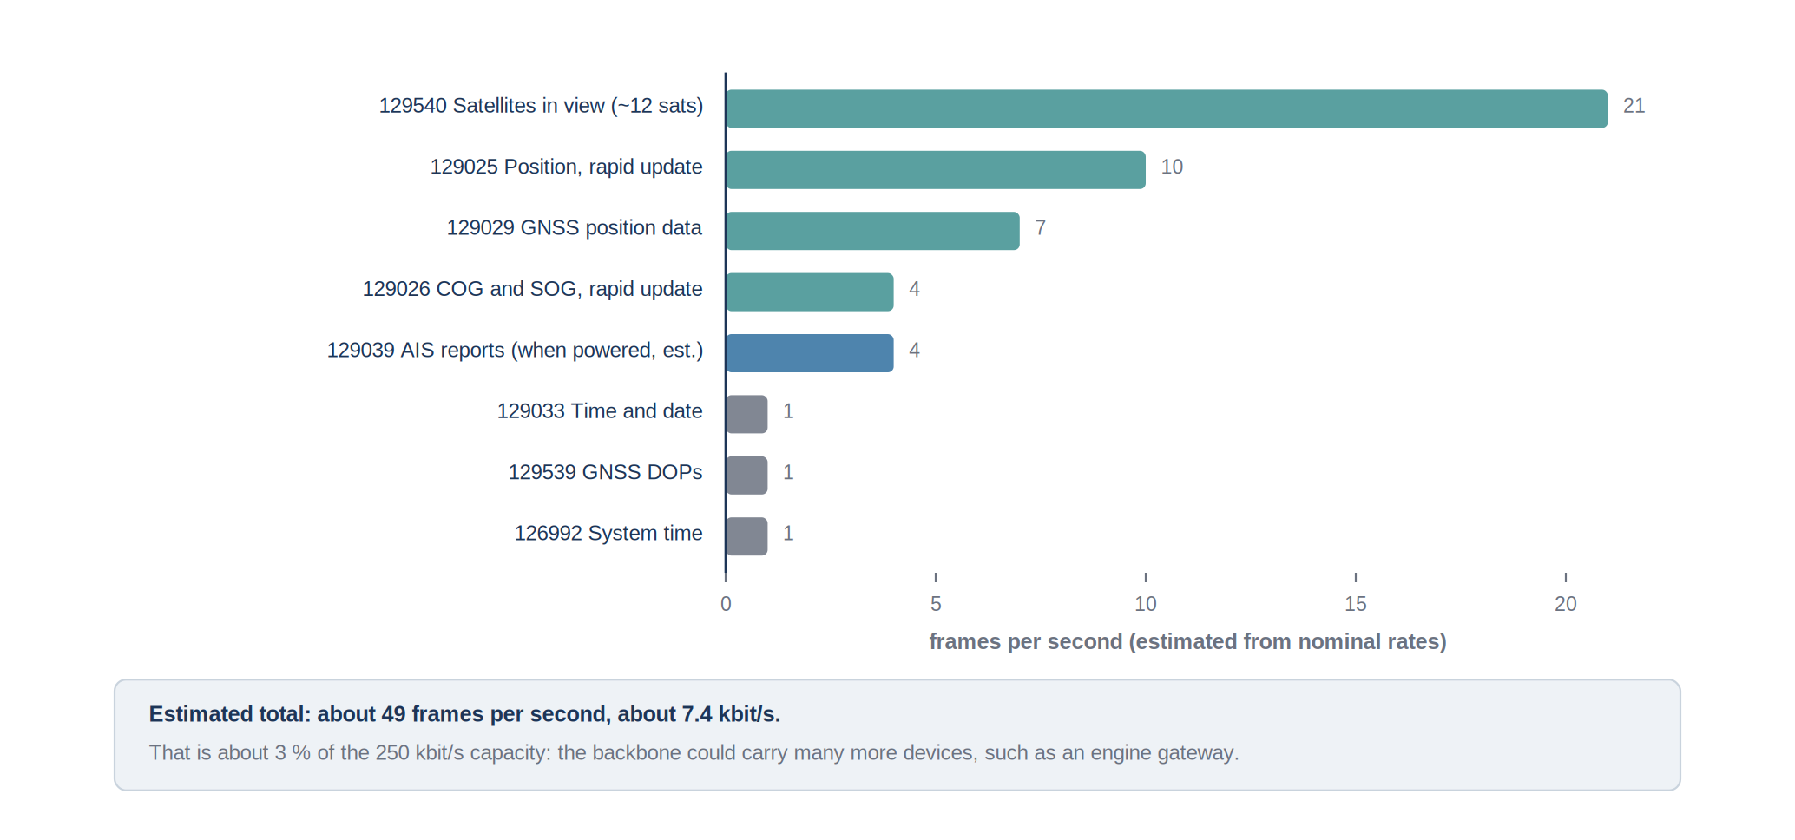
Figure 12: Estimated number of frames per second for each PGN and load of the bus
In total, the GPS receiver sends about fifty frames per second, which uses only about 3 % of the capacity of the bus. The network could therefore receive many more devices, such as an engine gateway, without any risk of saturation. The frames, however, do not arrive regularly: the receiver sends its messages in bursts of a few frames in less than a millisecond, which caused one of the problems described in Section 5.9.

5.6 Explanation of the PGNs
This section explains the PGNs received on the vessel, what each one contains and how it is decoded. All the PGNs of the GPS receiver were sent by the same source, address 0x15.

5.6.1 PGN 129025 - Position, rapid update
This is the main position message. It is short, a single frame, so that it can be sent ten times per second. It only contains the latitude and the longitude.
Table 12: Layout of PGN 129025
Bytes | Field | Type | Resolution
0 to 3 | latitude | signed 32-bit integer | 1e-7 degree, about 1 cm
4 to 7 | longitude | signed 32-bit integer | 1e-7 degree

A positive latitude is north of the equator, a positive longitude east of Greenwich. The value 0x7FFFFFFF means that no position is available, for example before the receiver has a fix.

5.6.2 PGN 129026 - Course and speed over ground
This message gives the direction of the movement of the vessel, the course over ground or COG, and its speed relative to the seabed, the speed over ground or SOG. Both are computed by the GPS receiver from successive positions.
Table 13: Layout of PGN 129026
Bytes | Field | Type | Resolution
0 | sequence identifier | 8-bit integer | links messages computed at the same time
1 | COG reference | 2 bits | 0 = true north, 1 = magnetic north
2 to 3 | course over ground | unsigned 16-bit integer | 1e-4 radian
4 to 5 | speed over ground | unsigned 16-bit integer | 0.01 m/s
6 to 7 | reserved | - | -

The course is converted from radians into degrees, and the speed from metres per second into knots for the display, one knot being 0.514 m/s. These quantities must not be confused with the heading and the speed through the water, which come from a compass and a log and which were not available on this vessel.
At very low speed, when the vessel is moored or drifting, the course over ground becomes erratic, because the movement between two positions is as small as the noise of the positions. This was observed at the quay and is a normal behaviour of every GPS receiver.

5.6.3 PGN 129029 - GNSS position data
This message contains the complete GPS fix: date and time, latitude and longitude with a very high resolution, altitude, type of fix, number of satellites used and dilution of precision. With 43 bytes, it is sent as a fast-packet message of 7 frames, once per second. The position is taken from PGN 129025, which is faster, and PGN 129029 is used for the information that PGN 129025 does not contain, mainly the type of fix and the number of satellites. When one of its 7 frames is lost, the message is incomplete and is rejected.
Table 14: Main fields of PGN 129029
Bytes | Field | Type | Resolution
0 | sequence identifier | 8-bit integer | -
1 to 2 | date | unsigned 16-bit integer | days since 1 January 1970
3 to 6 | time | unsigned 32-bit integer | 0.0001 s since midnight
7 to 14 | latitude | signed 64-bit integer | 1e-16 degree
15 to 22 | longitude | signed 64-bit integer | 1e-16 degree
23 to 30 | altitude | signed 64-bit integer | 1e-6 m
31 | type of system and method of fix | 2 x 4 bits | GPS, GLONASS, differential fix...
33 | number of satellites used | 8-bit integer | 1
34 to 35 | HDOP | signed 16-bit integer | 0.01
36 to 37 | PDOP | signed 16-bit integer | 0.01
38 to 41 | geoidal separation | signed 32-bit integer | 0.01 m

5.6.4 PGN 129033 and 126992 - Time and date
Both messages give the date and the time of the GPS receiver, which come from the atomic clocks of the satellites. PGN 129033 contains the date as a number of days since 1 January 1970, the time as a number of tenths of milliseconds since midnight, and the offset of the local time in minutes. PGN 126992 gives the same date and time and adds the source of the time. They are used to date each value; without them, no value can be stored in the database, which requires a date for every observation.
Table 15: Layout of PGN 129033
Bytes | Field | Type | Resolution
0 to 1 | date | unsigned 16-bit integer | days since 1 January 1970
2 to 5 | time | unsigned 32-bit integer | 0.0001 s since midnight
6 to 7 | local offset | signed 16-bit integer | minutes

For example, the bytes A8 50 give 20 648 days, which is 14 July 2026, and the bytes A0 04 6F 14 give 342 820 000, that is 34 282 seconds after midnight, or 09:31:22 UTC. The local offset of 120 minutes corresponds to the summer time of Spain.

5.6.5 PGN 129539 and 129540 - Quality of the fix
PGN 129539 gives the dilution of precision of the fix. The horizontal value, HDOP, shows how the position of the satellites in the sky affects the accuracy of the position: a value close to 1 means a good geometry, a value above 5 a poor one. PGN 129540 lists the satellites in view with, for each of them, its number, its elevation, its azimuth and the strength of its signal. It is the longest message of the network, about twenty frames every second with twelve satellites in view. These two messages make it possible to judge afterwards if a position can be trusted.
Table 16: Layout of PGN 129539
Bytes | Field | Type | Resolution
0 | sequence identifier | 8-bit integer | -
1 | desired and actual mode | 3 + 3 bits | 1D, 2D, 3D or automatic
2 to 3 | HDOP, horizontal | signed 16-bit integer | 0.01
4 to 5 | VDOP, vertical | signed 16-bit integer | 0.01
6 to 7 | TDOP, time | signed 16-bit integer | 0.01

Table 17: Content of PGN 129540 for each satellite
Field | Type | Resolution
satellite number (PRN) | 8-bit integer | -
elevation above the horizon | signed 16-bit integer | 1e-4 radian
azimuth | unsigned 16-bit integer | 1e-4 radian
signal to noise ratio | signed 16-bit integer | 0.01 dB
status | 4 bits | tracked, used in the fix, not tracked

5.6.6 PGN 129038 and 129039 - AIS position reports
The AIS transponder publishes on the network the reports it receives by radio from the surrounding vessels: PGN 129038 for class A vessels, such as large commercial ships, and PGN 129039 for class B vessels, such as small working or leisure boats. Each report contains the MMSI of the vessel, its nine-digit identity, its position, its course and its speed. These messages are sent as fast-packet messages, at a rate that depends on the traffic and on the speed of the vessels, from a few seconds to a few minutes.
On NMEA 2000, the transponder publishes these reports in the binary layout of the network, with latitude and longitude as integers in units of 1e-7 degree and the course in units of 1e-4 radian. This is different from the format of the AIS radio messages, and using the wrong format at first gave positions hundreds of kilometres away from the vessel.

5.6.7 PGN 127488 and 127489 - Engine parameters
The engine messages give the engine speed, in quarters of a revolution per minute, the boost pressure and the tilt of the engine for PGN 127488, and the temperatures, pressures, operating hours and alarms for PGN 127489. Their decoding was prepared, but they were never received on the vessel, because the engine is not connected to the NMEA 2000 network. This is explained in Section 5.7 and is the first point of improvement of the project.

5.7 Tests on board the vessel
The vessel was visited only a few times, each time to check on the real network what had been validated on the bench. On board, the ESP32 board was connected to a free T-connector of the backbone. It was supplied by the USB cable of the laptop, which also displayed the monitor, and the internet connection needed for the WAN phase was provided by the hotspot of a personal phone, because the 4G router of the vessel had no power supply.
Table 18: Observations made on board
Observation | Consequence
Only one device transmits on the backbone, the GPS receiver at address 0x15 | its PGNs match those tested on the bench
The AIS transponder is invisible unless the backbone itself is supplied with 12 V | the power of the backbone must be checked before any test
No engine message is ever received | the engine is not connected to the NMEA 2000 network
Depth message is received from the KTD-TM520 at address 0x15 | The KTD-TM520 is connected to the GPS it sends the depth on the same address
The rates of the GPS messages match the nominal rates | the decoding validated on the bench works on the real network
Bursts of several frames within a millisecond | a reception fault appeared that the bench had not shown

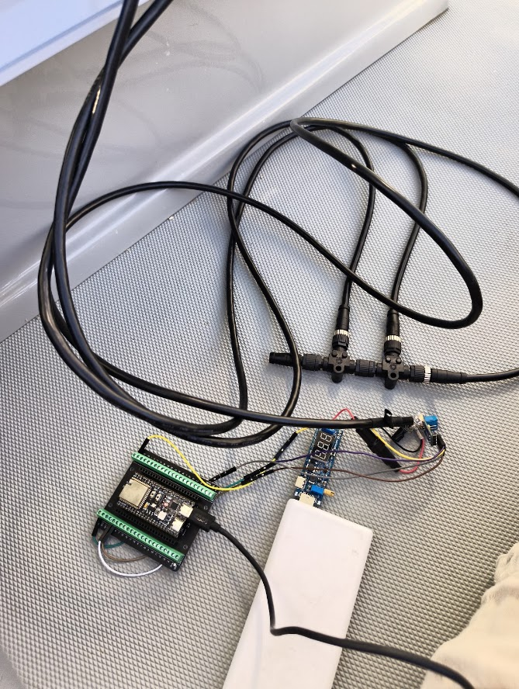
The most important observation concerns the engine. The engine speed and temperature are shown on the display at the helm, so engine messages were expected on the network. None was ever received. Following the cables showed that the display is connected to the engine by a dedicated harness from the manufacturer, which is not linked to the NMEA 2000 backbone. It was not possible to connect the engine to the network during the internship, so the engine data could not be acquired; this is a point of improvement described in Section 5.10.

Figure 13: Test on board: ESP32 connected to the backbone through a T-connector

5.8 Local display and link to the laboratory

5.8.1 Local web page (LAN)
Once the decoding worked in the monitor, a web page was requested to display the values more clearly. The ESP32 creates its own Wi-Fi access point, with the network name NMEA2000, and serves a page at the address 192.168.4.1. Any phone or laptop connected to that network can open the page, without internet access. The page refreshes the values every second and shows the age of each value, so that a value that is no longer updated is visible at once.
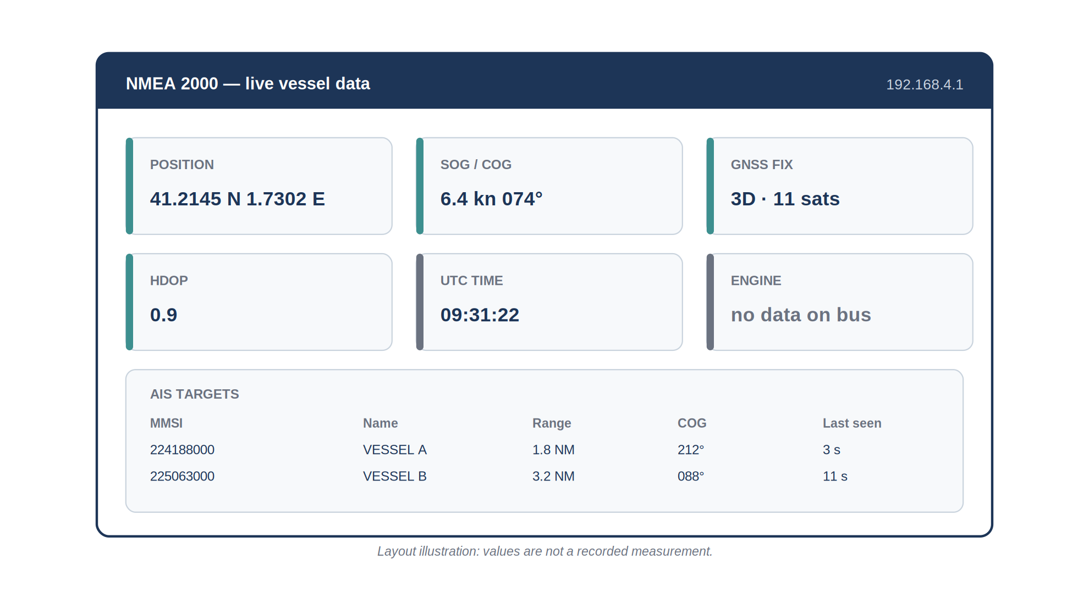
Figure 14: Local web page served by the ESP32 on its own Wi-Fi access point

5.8.2 Link to the laboratory server (WAN)
The last phase added the transmission of the values to the laboratory. While keeping its access point, the ESP32 also connects as a client to another Wi-Fi network that has internet access: during the tests, the hotspot of a phone. The values are then sent once per second to the server of the observatory, where they are stored in a database that follows the OGC SensorThings standard, the same one used for the fixed sensors of OBSEA. In that database, the vessel is a Thing with a Location, and each quantity, such as the position or the speed, is a Datastream to which the successive values, called Observations, are attached with their date.
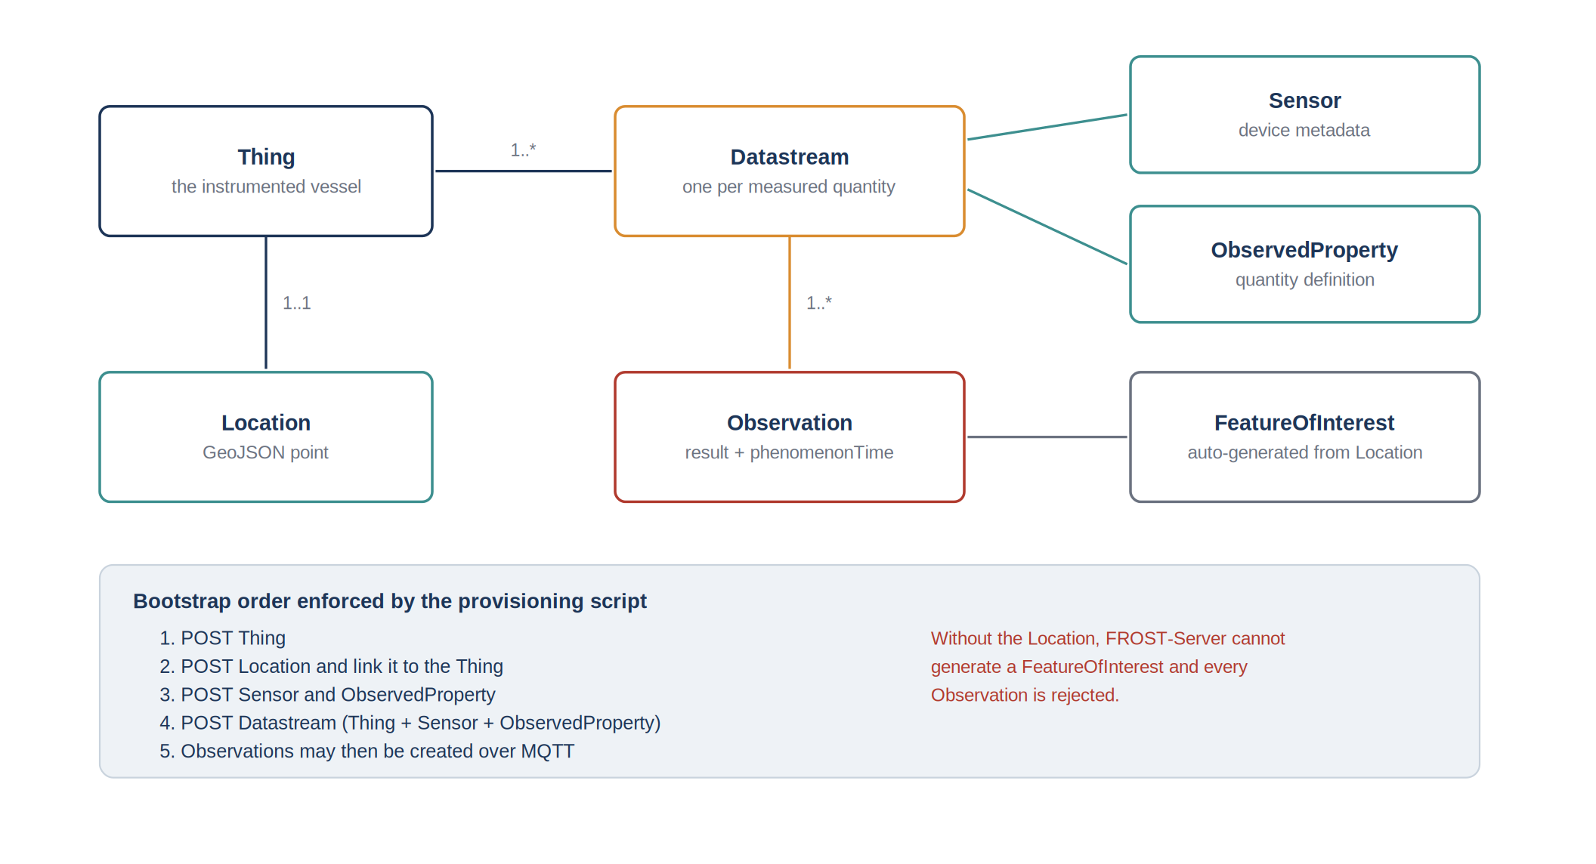
Figure 15: Organisation of the data of the vessel in the SensorThings database
The values are sent with MQTT, a light messaging protocol well suited to an unstable mobile link. The server of the laboratory was set up with the help of its administrator. The position observations of the vessel were confirmed in the database at the rate of one value per second.

5.9 Problems encountered and their resolution
Reaching the final result required solving several problems, most of them found and solved on the simulation bench, and some only visible on board.
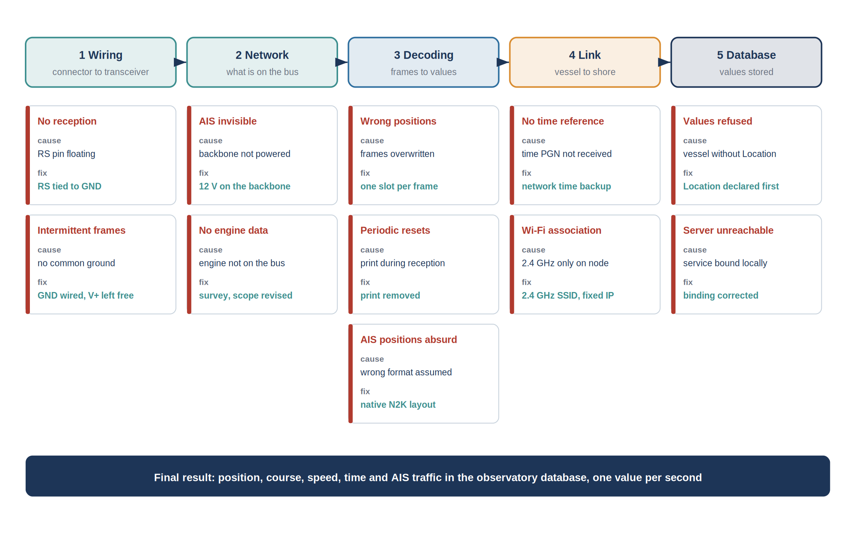
Figure 16: Problems met along the chain, their cause and their resolution
No reception at all. When the transceiver was first connected, no frame was received. Measurements on the transceiver showed that its RS pin was not connected, which kept it in standby mode. Connecting RS to the ground solved the problem immediately.
Intermittent reception. With some wirings, frames were received for a while and then lost. The drop cable had been wired with CAN H and CAN L only. Connecting the ground of the network to the ground of the board, while leaving the power conductor free, made the reception stable.
Wrong positions. On the vessel, some positions were wrong at random, while everything was correct on the bench. Comparing the raw bytes and the decoded values in the monitor showed that the frames were correct and that the error came from the receiver: during a burst, a frame was overwritten by the next one before being read. Giving each incoming frame its own storage place solved the problem. The simulator was then modified to send bursts, so that the correction could be tested on the bench.
Periodic resets. The board restarted by itself every few minutes. The cause was a message printed to the monitor at the exact moment a frame was received, which the microcontroller does not allow at that moment. Removing that print stopped the resets.
Incomplete GPS fix. When one of the 7 frames of PGN 129029 was lost, the reassembled message could overwrite a good position. The position is now taken only from PGN 129025, and an incomplete PGN 129029 is rejected.
AIS positions far away. The first AIS targets appeared hundreds of kilometres away. The decoding followed the format of the AIS radio messages instead of the binary layout of NMEA 2000. Rewriting it according to the NMEA 2000 layout gave correct positions.
AIS transponder invisible. On board, the transponder was working but none of its messages appeared on the network. Its NMEA 2000 interface only starts when the backbone is supplied with 12 V; once the backbone was supplied, the AIS messages appeared.
No time reference. During the first tests, no time message was received and the values could not be dated. A second time source was added: the ESP32 takes the time from an internet time server as soon as it is connected. The GPS time is used first, the internet time as a backup.
Wi-Fi association. The ESP32 sometimes failed to join the Wi-Fi network, and its address changed from one start to the next. The ESP32-S3 only works on the 2.4 GHz band, so it was configured on a 2.4 GHz network, and a fixed address was reserved for it on the router.
Values refused by the database. The first values sent to the server were all refused. In the SensorThings model, the vessel must have a Location before any value can be stored; it had been declared without one. Declaring the Location first solved the problem.
Server unreachable from outside. Once installed, the database answered on the server itself but not from outside the laboratory, because the service only accepted local connections. The configuration was corrected with the administrator of the server.
Engine data missing. This problem could not be solved during the internship, because the engine is not connected to the network. It is the first improvement proposed below.

5.10 Limits and points of improvement
The chain works for the data present on the network of this vessel, but it is still a prototype. The points of improvement below come from the tests and from the remarks of the tutor, Joaquin DEL RIO, at the end of the internship.
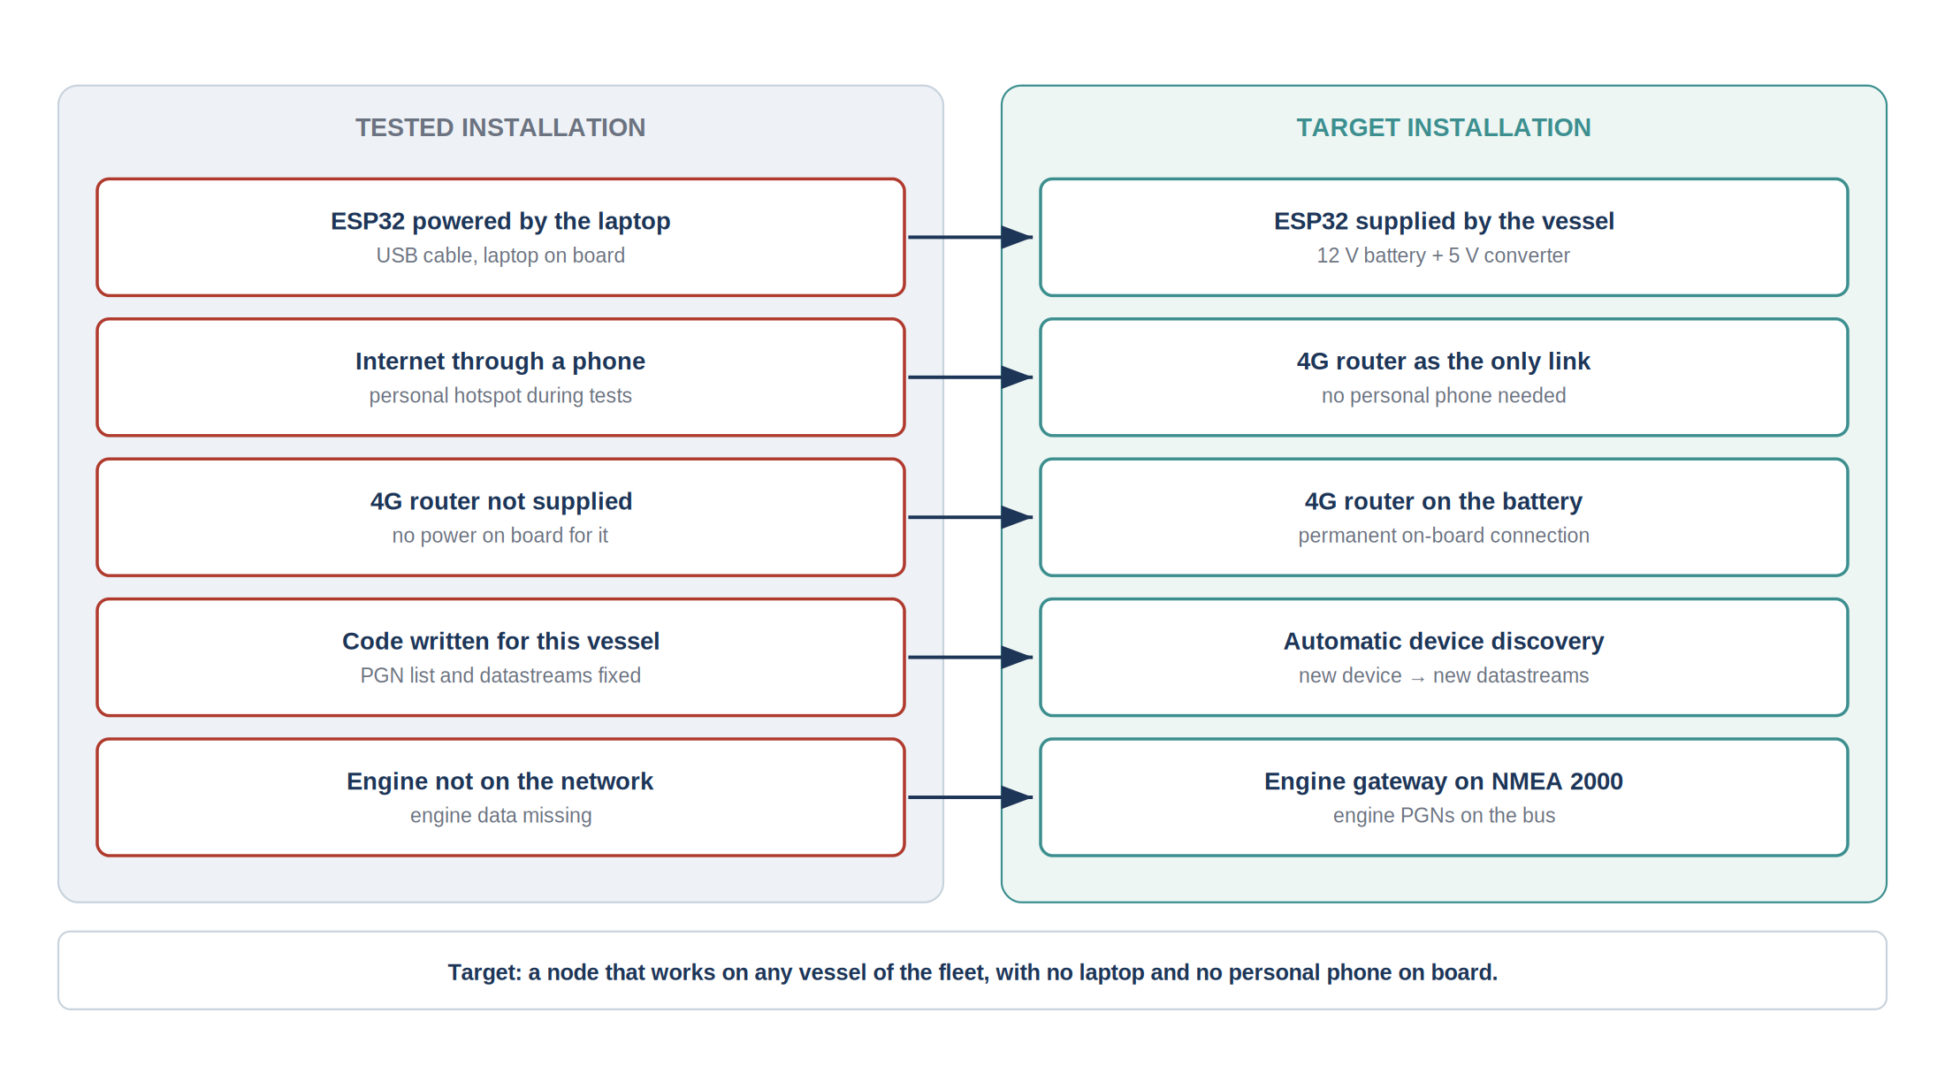
Figure 17: Installation as tested and target installation
Engine connection. The engine could not be connected to the NMEA 2000 network, so its data are missing. An engine gateway, which reads the engine link and publishes the engine PGNs on the network, would solve this. The receiver would then decode PGN 127488 and 127489 without any other change.
A general solution, not specific to this vessel. The current firmware was written for the devices of this vessel: it knows in advance which PGNs to decode and which datastreams to fill. The tutor asked for a more general system, in which a new device connected to the network is detected and added automatically, and which can be installed on several vessels. The management messages described in Section 5.2 make this possible: listening to the address claims and to the product information messages, the receiver can list the devices present and the PGNs they send, and create the corresponding datastreams in the database automatically. Each receiver would also identify its vessel, so that the same firmware could run on the whole fleet of the laboratory.
Power of the 4G router. During the tests, the internet connection was provided by the hotspot of a personal phone, because the 4G router of the vessel had no power supply. The router should be connected to the battery of the vessel, so that the connection is available permanently without any personal device on board.
Autonomous power of the ESP32. On board, the ESP32 had to be connected to the laptop to be supplied. A permanent installation needs a board supplied by the vessel, through a converter from the 12 V battery to 5 V, placed in a closed box protected from water, so that no laptop is needed on board.
Operation without network coverage. Far from the coast, the mobile network is lost and the values produced during that time are not sent. A small memory on the board could keep them and send them when the connection returns.
Table 19: Summary of the points of improvement
Point | Origin | Proposed solution
Engine data missing | tests on board | engine gateway to NMEA 2000
System specific to one vessel | request of the tutor | automatic detection of devices and PGNs, one firmware for all vessels
Router without power | tests on board, request of the tutor | router supplied by the battery of the vessel
ESP32 supplied by the laptop | tests on board | 12 V to 5 V converter from the battery, waterproof box
Values lost outside coverage | tests on board | local memory and delayed sending

6. Project management

6.1 Autonomy and supervision
The internship was carried out mostly in autonomy. The tutor, Joaquin DEL RIO, set the direction of the work and adjusted it step by step: each new objective, the local web page and then the link to the server, was defined with him once the previous one was working. He was also consulted when a problem blocked the work for too long, for example to access the vessel or the server of the laboratory. Between these points, the choice of methods, the organisation of the tests and the solving of the problems were done independently.
This way of working had a clear advantage: the work always followed the needs of the laboratory, which changed as the results appeared. It also required a personal organisation, to decide what to test, in which order, and when a trip to the vessel was worth it.

6.2 Chronology of the work
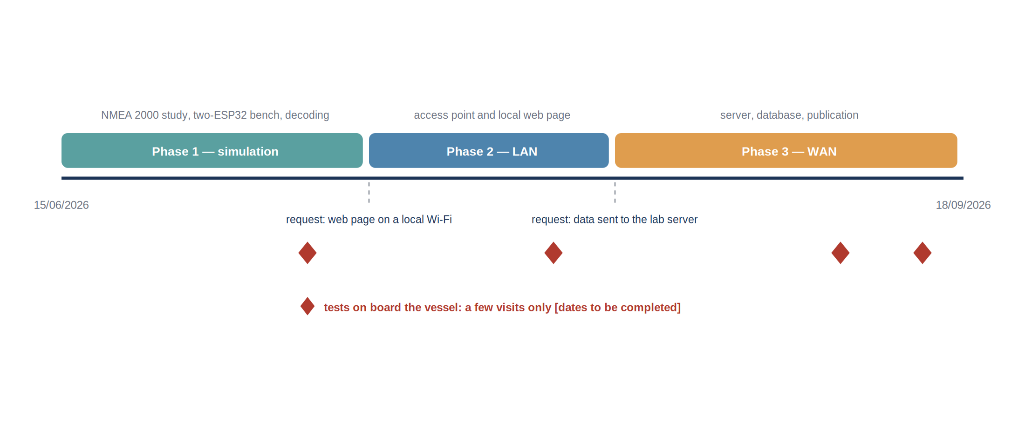
Figure 18: Chronology of the internship and of the tests on board
The work followed the three phases described in Chapter 5. The first weeks were spent studying the NMEA 2000 standard and building the simulation bench, until the receiver decoded correctly all the PGNs sent by the simulator. The second phase added the Wi-Fi access point and the local web page. The third phase added the connection to the laboratory server and the storage in the database. The tests on board were placed at the end of each phase, to confirm on the real network what had been validated on the bench.
Table 20: Evolution of the objectives
Phase | Request | Result
1 - Simulation | receive and decode the NMEA 2000 frames | PGNs of the GPS decoded and checked in idf.py monitor
2 - LAN | display the values more clearly | Wi-Fi access point and web page on the ESP32
3 - WAN | send the values to the laboratory | values stored in the SensorThings database at one per second
End of internship | make the system general and autonomous | points of improvement defined, see Section 5.10

6.3 Organisation of the tests on board
Because each trip to the vessel took time and depended on its availability, every visit was prepared in the laboratory with a precise objective and a list of checks, so that the time on board was used only to confirm results and to observe what could not be simulated.
Table 21: Visits to the vessel
Visit | Date | Objective | Main result
1 | 07/07/2026 | check the wiring and the reception of the real GPS | Successful but no AIS
2 | 29/07/2026 | check the AIS and the other devices of the network and test the local web page on board | Successful
3 | 04/09/2026 | test the sending of the values to the server | Unsuccessful
4 | 15/09/2026 | test the sending of the values to the server | Successful but still no engine frames

Each visit followed the same routine: check the resistance between CAN H and CAN L and the supply of the backbone, connect the ESP32 to a free T-connector, open the monitor and compare the PGNs received with the list expected. Any unexpected behaviour was noted and, back in the laboratory, reproduced on the simulation bench whenever possible.

6.4 Working method
The main methodological choice was to work on the simulation bench as much as possible. Since the vessel is not always available and a trip to the harbour takes time, every new function was first developed and debugged with the two ESP32 boards, and the vessel was used only for validation. When a problem appeared on board, the aim was to reproduce it on the bench, for example by making the simulator send bursts of messages, and to solve it there.
Debugging relied mainly on the monitor of ESP-IDF. Printing the raw bytes next to the decoded values made it possible to check each field by hand and to find the source of an error quickly. The code was kept under version control on GitHub; the files were sent folder by folder, because sending everything at once failed on the connection of the laboratory, and the build files were excluded from the repository.

6.5 Difficulties and how they were handled
Table 22: Difficulties met during the internship
Difficulty | Effect | Response
Limited access to the vessel | few tests on board possible | simulation bench with two ESP32, vessel used for validation only
Engine not connected to the network | engine data impossible to acquire | scope focused on the GPS and AIS data, engine gateway proposed
No power for the 4G router on board | no permanent internet on board | tests through the hotspot of a phone, router supply proposed
ESP32 supplied by the laptop | installation not autonomous | autonomous supply from the battery proposed
Server of the laboratory managed by an administrator | dependence on his availability | requests prepared in advance, server set up together

6.6 Handover
The firmware of the receiver and of the simulator, the configuration of the server and the list of the datastreams are available in the GitHub repository of the project, so that the work can be continued. The simulation bench remains a useful tool for the next steps: any new PGN, such as those of an engine gateway, can be added to the simulator and decoded on the bench before going to the vessel.

7. Conclusion
The object of this work was to make the measurements circulating on the NMEA 2000 network of a working vessel available in a standardised scientific database. That objective was reached: an acquisition node based on an ESP32-S3 microcontroller reads the vessel backbone in a strictly passive way, decodes the parameter groups carrying position, course, speed, heading, water depth, engine parameters and surrounding traffic, and publishes the corresponding observations to a FROST-Server instance implementing the OGC SensorThings API, hosted on the infrastructure of the laboratory. Position observations were confirmed present in the production database at the nominal rate of one hertz. A local web dashboard, served by the node on the on-board network, gives the crew the current values independently of the availability of the shore link.
The work also produced results that are reusable beyond this particular installation. The reception path was corrected on two defects characteristic of interrupt-driven acquisition, namely the reuse of a static buffer between frames and the presence of a non-reentrant call in interrupt context, and the corresponding solutions, a pool of rotating slots and the exposure of diagnostic counters outside interrupt context, are applicable to any acquisition of that class. The provisioning constraints of the server, and in particular the necessity of a location entity before any observation can be accepted, are documented in a script that reproduces the bootstrap in the correct order. The wiring conventions of the marine bus, and the pitfalls attached to them, are recorded in the annexes.
Three limitations bound the result. The nominal publication path carries no application-level acknowledgement, so an isolated loss of an observation is not detected. The node holds no local buffer, so measurements produced outside network coverage are lost rather than deferred. The decoding covers the standard parameter groups only, so any manufacturer-specific extension present on the bus is ignored.
The perspectives follow from those limitations, and are ordered here by the ratio of their value to their cost. Publishing at quality of service 1 rather than 0 would close the most probable loss mode; the change is confined to the publication task and is estimated at one to two days of work, with no material cost. Adding a local store-and-forward buffer would allow operation outside coverage; a serial flash memory of a few megabytes, of the order of two euros, is sufficient to hold several days of observations at the current rate, and the firmware work is estimated at one to two weeks, the difficulty lying in the reconciliation of deferred observations with the real-time stream rather than in the storage itself. Extending the decoding to the engine parameter groups specific to the manufacturer would require access to the corresponding documentation and is estimated at one week once that documentation is available. Finally, the replication of the installation on other vessels of the laboratory is now essentially a matter of assembly and configuration: the material cost per node is of the order of fifty euros excluding the router, and the installation procedure prepared during the handover is designed to be executed without reading the firmware.
A fourth direction, of a different nature, is opened by the availability of these data. The joint exploitation of the engine parameters, the speed over ground and the speed through water gives access to the fuel consumption of the vessel as a function of its operating point, and therefore to a quantified basis for reducing it. That analysis is outside the scope of the internship, but it is the first use of the acquired data that the laboratory identified once the chain became operational.

Bibliography
[1] National Marine Electronics Association, "NMEA 2000 Standard for Serial-Data Networking of Marine Electronic Devices", version 1.301, NMEA, Severna Park, MD, USA, 2010.
[2] International Organization for Standardization, "ISO 11783-3: Tractors and machinery for agriculture and forestry - Serial control and communications data network - Part 3: Data link layer", ISO, Geneva, Switzerland, 2018.
[3] Open Geospatial Consortium, "OGC SensorThings API Part 1: Sensing Version 1.1", OGC 18-088, 2021. [Online]. Available: https://docs.ogc.org/is/18-088/18-088.html
[4] Fraunhofer IOSB, "FROST-Server documentation", 2024. [Online]. Available: https://fraunhoferiosb.github.io/FROST-Server/
[5] Espressif Systems, "ESP-IDF Programming Guide, Two-Wire Automotive Interface (TWAI)", version 5.5, 2024. [Online]. Available: https://docs.espressif.com/projects/esp-idf/
[6] T. Lappalainen, "NMEA2000 library for Arduino and ESP32", GitHub repository, 2024. [Online]. Available: https://github.com/ttlappalainen/NMEA2000
[7] Texas Instruments, "SN65HVD23x 3.3-V CAN Bus Transceivers", datasheet SLOS346R, 2019.
[8] OASIS, "MQTT Version 3.1.1 - OASIS Standard", 2014. [Online]. Available: https://docs.oasis-open.org/mqtt/mqtt/v3.1.1/os/mqtt-v3.1.1-os.html
[9] J. del Río et al., "The New Seafloor Observatory (OBSEA) for Remote and Long-Term Coastal Ecosystem Monitoring", Sensors, vol. 11, no. 6, pp. 5850–5872, 2011.
[10] SARTI, "Remote Acquisition and Data Processing Systems - research group presentation", Universitat Politècnica de Catalunya. [Online]. Available: https://eel.upc.edu/en/research/folder-groups/sarti-remote-acquisition-and-data-processing-systems
[11] OBSEA, "Expandable Seafloor Observatory - overview", Universitat Politècnica de Catalunya. [Online]. Available: https://obsea.es/about/overview.php
[12] Kvaser, "NMEA 2000 higher layer protocol description". [Online]. Available: https://kvaser.com/about-can/higher-layer-protocols/nmea-2000/
[13] United Nations, "Transforming our world: the 2030 Agenda for Sustainable Development", resolution A/RES/70/1, 2015.
[14] Universitat Politècnica de Catalunya, "Pla d'igualtat de la UPC", Barcelona, Spain. [Online]. Available: https://www.upc.edu/igualtat

Annexes

Annexe A - Wiring table of the acquisition node
Table 23: Connections of the acquisition node
Signal | M12 pin | Node terminal | Remark
Shield | 1 | chassis | connected at one end only
Bus power positive | 2 | not connected | the node has its own supply
Bus ground | 3 | node ground | mandatory common reference
CAN H | 4 | transceiver CAN H | white conductor
CAN L | 5 | transceiver CAN L | blue conductor
Transceiver transmit | - | GPIO5 | configured but unused, reception only
Transceiver receive | - | GPIO4 | -
Transceiver mode | - | RS to ground | selects the high-speed mode

Annexe B - Provisioning of the server entities
The following commands create the entity graph in dependency order. The identifiers returned by the server are substituted into the subsequent requests and then written into the configuration of the node.
POST /FROST-Server/v1.1/Things
{ "name": "Vessel <name>", "description": "Instrumented working vessel" }

POST /FROST-Server/v1.1/Things(1)/Locations
{ "name": "Berth", "encodingType": "application/geo+json",
"location": { "type": "Point", "coordinates": [1.7302, 41.2145] } }

POST /FROST-Server/v1.1/Sensors
{ "name": "Sportnav SPO25F", "encodingType": "text/html",
"metadata": "GNSS receiver, NMEA 2000" }

POST /FROST-Server/v1.1/ObservedProperties
{ "name": "Latitude", "definition": "http://...", "description": "Geodetic latitude" }

POST /FROST-Server/v1.1/Datastreams
{ "name": "Vessel latitude",
"observationType": "http://.../OM_Measurement",
"unitOfMeasurement": { "name": "degree", "symbol": "deg" },
"Thing": { "@iot.id": 1 }, "Sensor": { "@iot.id": 1 },
"ObservedProperty": { "@iot.id": 1 } }
The Location must exist and be linked to the Thing before any observation is published. Without it the server cannot generate the FeatureOfInterest and every observation is rejected.

Annexe C - Publication payload
Each observation is published on the topic associated with its datastream, with the following payload. The timestamp is the acquisition time recorded by the node, not the publication time.
topic: v1.1/Datastreams(3)/Observations
payload: { "result": 41.21453, "phenomenonTime": "2026-07-14T09:31:22Z" }

Annexe D - Decoding of a parameter group
The following extract illustrates the decoding of the position rapid update group. The reserved value test rejects the pattern that the standard defines as "data not available", which would otherwise be published as a valid coordinate.
/* PGN 129025 - Position, Rapid Update - single frame, 8 bytes */
static void decode_129025(const n2k_frame_t *f, vessel_state_t *st)
{
int32_t lat_raw = le32(&f->data[0]); /* 1e-7 degree units */
int32_t lon_raw = le32(&f->data[4]);

/* reserved pattern: quantity not available on this device */
if (lat_raw == INT32_MAX || lon_raw == INT32_MAX) {
st->pos.rejected++;
return;
}

st->pos.latitude = lat_raw * 1e-7;
st->pos.longitude = lon_raw * 1e-7;
st->pos.timestamp = now_utc(); /* NTP-disciplined clock */
st->pos.valid = true;
}

Annexe E - Bill of materials and indicative cost
Table 24: Indicative cost of one acquisition node
Item | Quantity | Indicative unit cost
ESP32-S3 development module | 2 | ~10€
SN65HVD230 transceiver board | 2 | ~5€
M12 five-pin drop cable and T connector | 3 | ~20€ + ~5€
Enclosure and mounting | 1 | ~5€
12 V to 5 V regulator | 1 | ~5€
Total per node, excluding the on-board router | 1 | ~100€

Annexe F - Photographic record
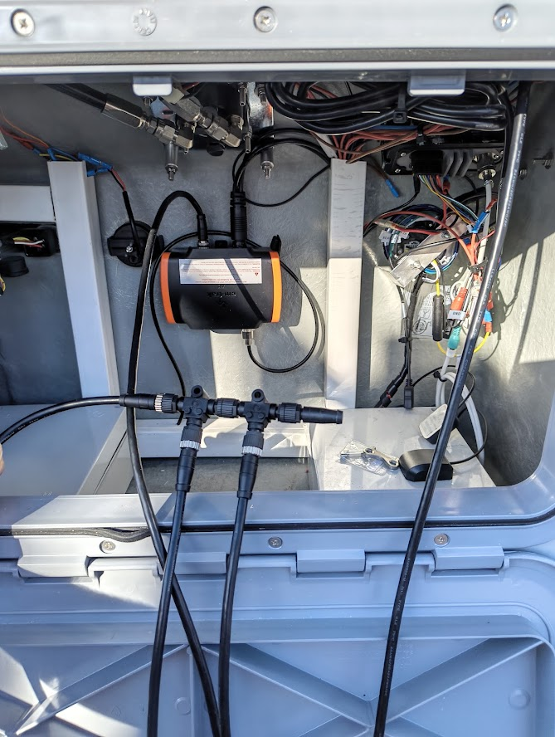
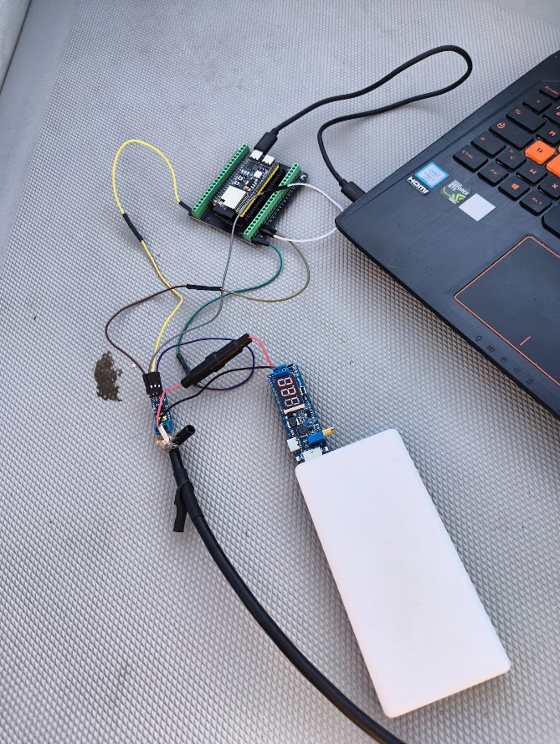
Figure 19: Acquisition node: microcontroller module, transceiver and M12 connection
Figure 20: Installation of the node on the instrumented vessel
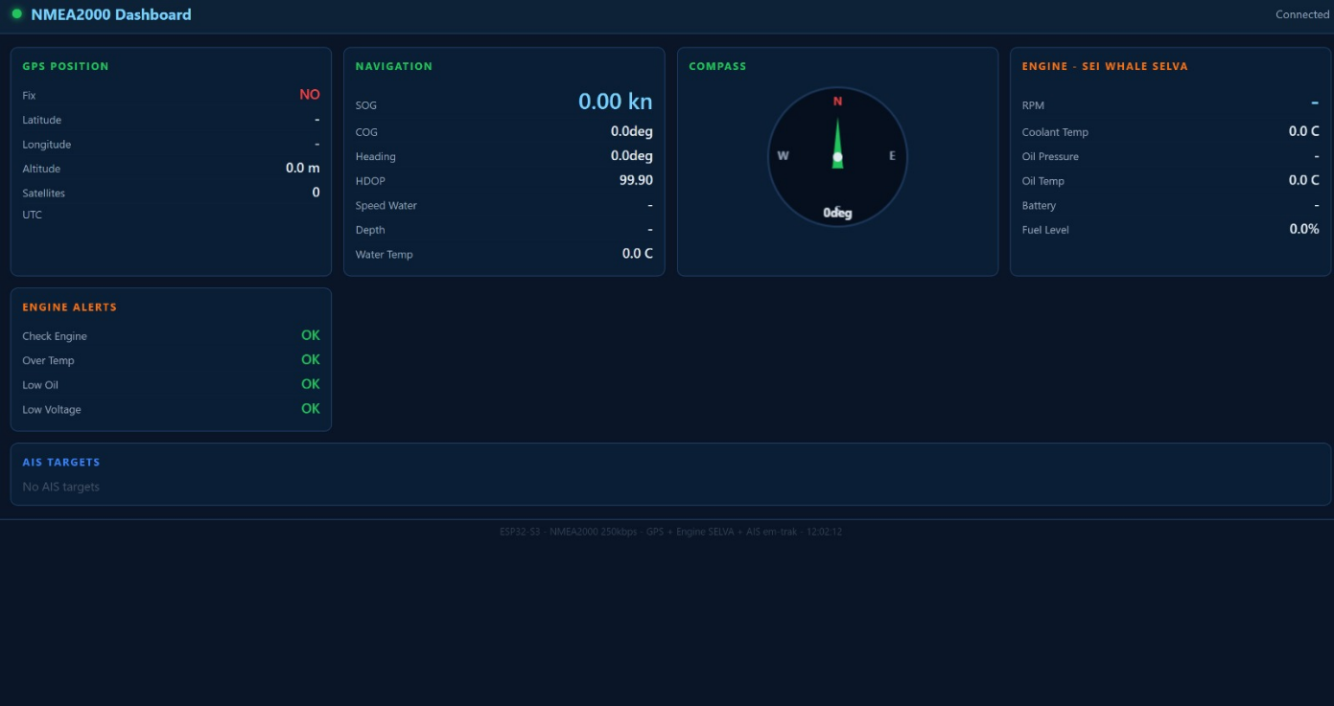
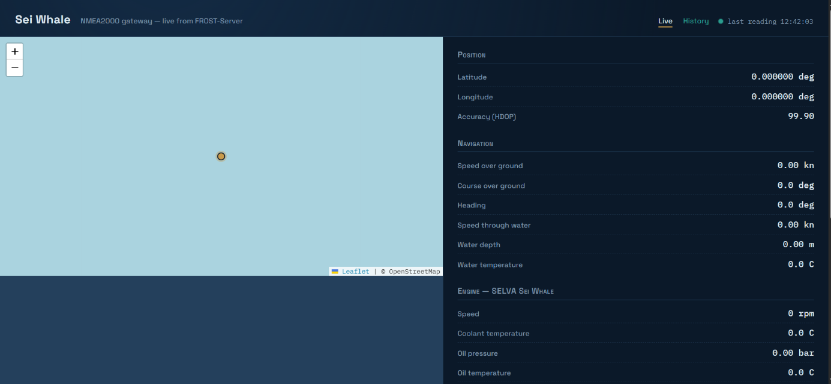
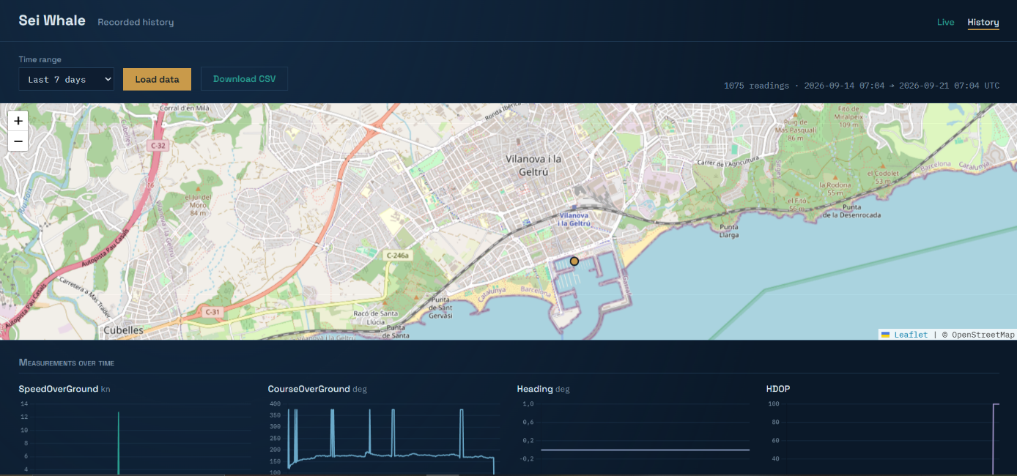
Figure 21: Local dashboard displaying live values during a sea trial
Figure 22: Observations retrieved from the production database over the REST interface

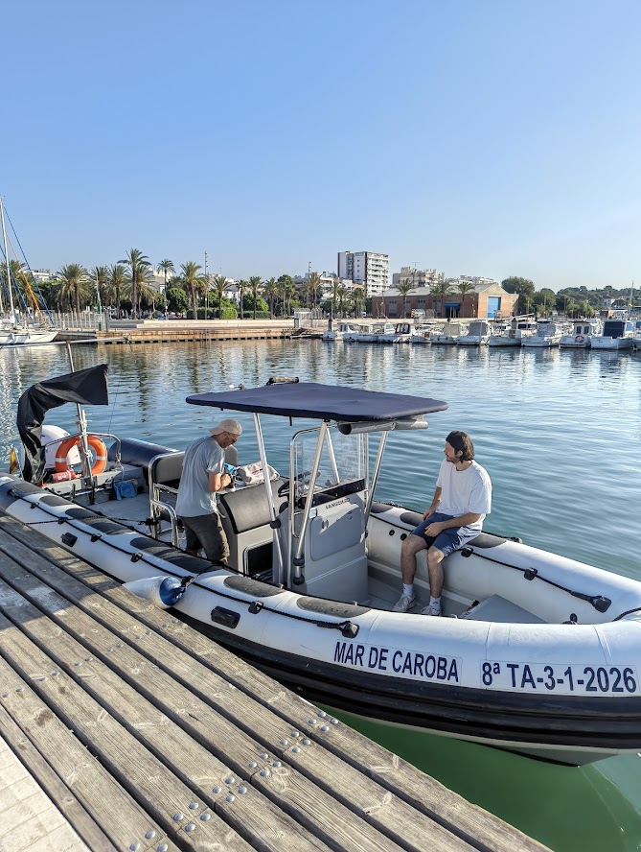
Figure 23 : SARTI UPC Boat used to dive at OBSEA
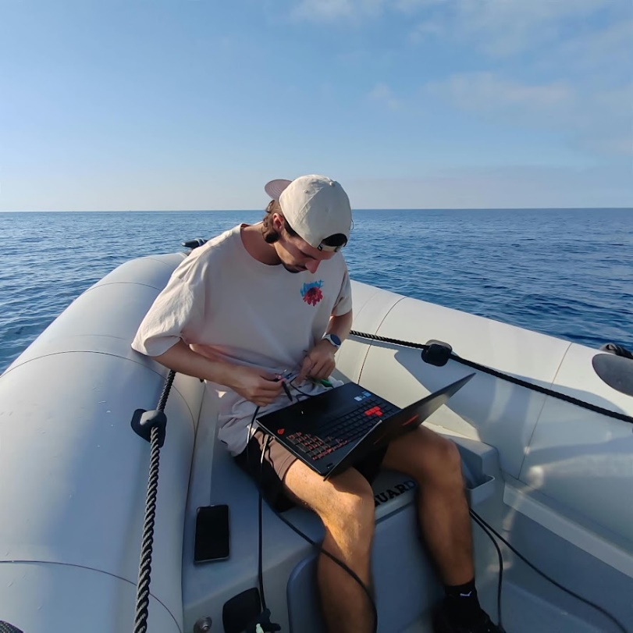
Figure 24 : Me working on the boat to acquire the data and do the testing
Abstract
Recent working vessels carry an NMEA 2000 network on which position, heading, speed, water depth, engine parameters and surrounding traffic circulate continuously. These measurements are displayed on board and then discarded. This report describes an acquisition chain that makes them available in a scientific database. An embedded node based on an ESP32-S3 microcontroller listens passively to the vessel backbone through a CAN transceiver, decodes the parameter groups of interest, filters the values declared unavailable by the standard, and publishes the resulting observations to a FROST-Server instance implementing the OGC SensorThings API and operated by the SARTI research centre of the Universitat Politècnica de Catalunya. Publication uses a lightweight messaging protocol over a mobile link, while the reference web interface of the server is used for provisioning and diagnostics. A local dashboard served by the node gives the crew the current values independently of the shore link. The chain was validated on a bench, at the dockside and at sea; position observations are stored in the production database at the nominal rate. The report also documents two defects of the interrupt-driven reception path and the provisioning constraints of the server, and states the limitations of the result together with the perspectives for its extension.
Résumé
Les navires de travail récents embarquent un réseau NMEA 2000 sur lequel circulent en permanence la position, le cap, la vitesse, la profondeur, les paramètres moteur et le trafic environnant. Ces mesures sont affichées à bord puis perdues. Ce rapport décrit une chaîne d'acquisition qui les rend disponibles dans une base de données scientifique. Un nœud embarqué fondé sur un microcontrôleur ESP32-S3 écoute passivement le bus du navire au travers d'un émetteur-récepteur CAN, décode les groupes de paramètres utiles, filtre les valeurs déclarées indisponibles par la norme, et publie les observations obtenues vers un serveur FROST mettant en œuvre l'API OGC SensorThings, exploité par le centre de recherche SARTI de l'Universitat Politècnica de Catalunya. La publication emprunte un protocole de messagerie léger sur liaison mobile, l'interface web de référence du serveur étant réservée au provisionnement et au diagnostic. Un tableau de bord local servi par le nœud restitue à l'équipage les valeurs courantes indépendamment de la liaison vers la terre. La chaîne a été validée au banc, à quai et en mer ; les observations de position sont enregistrées dans la base de production à la cadence nominale. Le rapport documente également deux défauts du chemin de réception sous interruption ainsi que les contraintes de provisionnement du serveur, et énonce les limites du résultat et les perspectives de son extension.
Keywords / Mots-clés
NMEA 2000, CAN bus, ESP32-S3, marine instrumentation, OGC SensorThings API, FROST-Server, MQTT, embedded acquisition, OBSEA.

